**ASSIGNMENT FINAL REPORT**

|  |  |  |  |
| --- | --- | --- | --- |
| **Qualification** | **BTEC Level 5 HND Diploma in Computing** | | |
| **Unit number and title** | **Unit 16: Computing Research Project** | | |
| **Submission date** | 11/11/2024 | **Date Received 1st submission** |  |
| **Re-submission Date** |  | **Date Received 2nd submission** |  |
| **Student Name** | Trinh Minh Hieu | **Student ID** | BH01236 |
| **Class** | IT0601 | **Assessor name** | Nguyen Thanh Trieu |
| **Student declaration**  I certify that the assignment submission is entirely my own work and I fully understand the consequences of plagiarism. I understand that making a false declaration is a form of malpractice. | | | |
|  |  | **Student’s signature** | Hieu |

**Grading grid**

|  |  |  |  |  |  |  |  |  |  |  |  |  |  |
| --- | --- | --- | --- | --- | --- | --- | --- | --- | --- | --- | --- | --- | --- |
| P1 | P2 | P3 | P4 | P5 | P6 | P7 | M1 | M2 | M3 | M4 | D1 | D2 | D3 |
|  |  |  |  |  |  |  |  |  |  |  |  |  |  |

|  |  |  |
| --- | --- | --- |
| **r Summative Feedback: r Resubmission Feedback:** | | |
| **Grade:** | **Assessor Signature:** | **Date:** |
| **Internal Verifier’s Comments:** | | |
| **Signature & Date:** | | |

Table of Contents

I. Introduction 10

II. Content 11

P1. Produce a research proposal that clearly defines a research question or hypothesis supported by a literature review. 11

1. Research Type 11

2. Overview of the Research 11

3. Research Context 12

4. Research Questions and Hypotheses 13

5. Project Objectives 14

6. Research Methods in the Project 16

6.1. Literature Review 16

6.2. Survey Method 16

6.3. Experimental Design 17

6.4. User Testing (Usability Testing) 17

6.5. Data Analytics and Performance Monitoring 17

6.6. Interviews and Focus Groups 17

6.7. Statistical Analysis 17

7. Project Implementation Plan 18

P2. Examine appropriate research methods and approaches to primary and secondary research. 20

1. Introduction to Research 20

2. Primary Research 21

3. Secondary Research 22

4. Comparison of Primary and Secondary Research 23

5. Quantitative Research in Primary and Secondary Approaches 24

6. Conclusion 24

M1. Evaluate different research approaches and methodology and make justifications for the choice of methods selected based on philosophical/theoretical frameworks. 24

1. Quantitative Research Approach 24

1.1. Explanation in Relation to Hypothesis/Theory 24

1.2. Advantages and Limitations 25

1.3. Ethical Considerations 25

1.4. Justification for Method Choice 25

2. Qualitative Research Approach 26

2.1. Explanation in Relation to Hypothesis/Theory 26

2.2. Advantages and Limitations 26

2.3. Ethical Considerations 26

2.4. Justification for Method Choice 27

3. Comparative Evaluation of Quantitative vs. Qualitative Methods 27

4. Rationale for Selecting Methods for This Project 27

P3. Conduct primary and secondary research using appropriate methods for a computing research project that consider costs, access and ethical issues. 28

1. Primary Research 28

1.1. Primary Data Collection Methods 28

1.2. Significance and Interpretation of Collected Data 29

1.3. Evaluating Collected Data Sources 29

1.4. Reviewing Related Documentation 29

1.5. Data Collection Methods Summary 30

2. Secondary Research 30

2.1. Secondary Data Collection Methods 30

2.2. Secondary Research Methods: Interviews and Surveys 30

3. Integration and Analysis 31

4. Ethical Considerations in Research 31

P4. Apply appropriate analytical tools, analyse research findings and data 31

1. Servant method selected 32

2. Survey form 32

3. Analyse research findings and data 36

3.1. What is your current level of English proficiency? 36

3.2. How often do you use the AI chatbot for learning English? 37

3.3. How easy was it to start using the chat bot? 38

3.4. How accurate do you find the chatbot in understanding your input? 39

3.5. How would you rate the chatbot’s response time? 40

3.6. How helpful is the chatbot in learning new vocabulary? 40

3.7. How confident do you feel in using English after interacting with the chat-bot? 42

3.8. Overall, how satisfied are you with the AI chatbot for learning English? 43

4. Summary of Findings 43

M2. Discuss merits, limitations, and pitfalls of approaches to data collection and analysis. 44

1. Strengths, Limitations, and Challenges of Survey and Interview Methods 44

2. Benefits and Limitations of Data Collection Tools Used 45

3. Comparison of Data Collection Methods and Tools for the Project 46

4. Recommendations for Improvement 47

D1. Critical Evaluation of Research Methods and Processes in a Computing Research Project 48

1. Introduction 48

2. Justification for Chosen Research Methods 48

3. Evaluation of Research Methods 50

4. Evaluation of Research Processes 51

5. Comparative Evaluation with Alternative Methods 51

6. Critical Reflection on Outcomes 52

7. Conclusion 52

P5. Communicate research outcomes in an appropriate manner for the intended audience. 53

1. Detailed Summary of Research Findings 53

2. Tailored Communication Strategies 53

3. Presentation of Research Findings 54

4. Recommendations and Implications 55

5. Interactive Q&A Session 55

M3. Coherently and logically communicate outcomes to the intended audience demonstrating how outcomes meet set research objectives. 56

1. Introduction: Summary of the Research Topic and Objectives 56

2. Highlighting the Importance of Understanding the Technology Project 56

3. Research Objectives (Aligned with the Group's Project) 57

4. Research Methodology (Aligned with the Group's Project) 57

5. Detailed Analysis of Project Implementation 58

6. Real-World Application of the Project 58

7. Research Findings (Aligned with the Group's Project) 59

8. Summary: Key Research Findings and Their Alignment with Research Objectives 59

D2. Communicate critical analysis of the outcomes and make valid, justified recommendations. 60

1. Critical Analysis of Outcomes 60

1.1. Summary of Key Findings 60

1.2. Impact of Research Findings 61

1.3. Comparison with Existing Theories 61

1.4. Reflections on Methodology 61

2. Justified Recommendations 62

2.1. Enhancing Product Features 62

2.2. Strengthen Deployment and Scalability 62

2.3. Implementation Plan 62

2.4. Expected Outcomes 63

3. Final Considerations 63

3.1. Quality Assurance 63

3.2. Market Readiness 63

3.3. Scalability and Maintenance 63

P6. Reflect on the effectiveness of research methods applied for meeting objectives of the computing research project 64

1. Introduction 64

2. Evaluation of the Research Methods Applied 64

2.1. Literature Review 64

2.2. Interviews with Industry Experts 65

2.3. Case Studies 65

3. Alignment Between Research Methods and Project Objectives 66

3.1.Alignment with Project Objectives 66

3.2. Extent to Which Research Methods Met Project Goals 66

4. Limitations and Challenges in Implementing the Research Methods 67

4.1. Limitations in the Literature Review 67

4.2. Challenges in Conducting Expert Interviews 67

4.3. Limitations in Case Study Analysis 67

4.4. Impact on the Achievement of Project Objectives 68

5. Lessons Learned from the Use of Research Methods 68

5.1. Key Lessons and Insights 68

5.2. Implications for Future Computing Research Projects 68

6. Conclusion 69

6.1. Overall Assessment of Research Methods 69

6.2. Key Takeaways 69

P7: Consider alternative research methodologies and lessons learns in view of the outcomes. 69

1. Alternative Research Methodologies 69

1.1. Surveys with Larger Samples 69

1.2. Focus Groups 70

1.3. Longitudinal Studies 70

1.4. Usability Testing with Observation 71

1.5. Experimental Studies 71

2. Lessons Learnt from Current Methodologies 72

2.1. Strengths of Current Methods 72

2.2. Limitations of Current Methods 72

2.3. Key Lessons Learnt 72

3. Implications for Future Research Projects 73

3.1. Combining Alternative and Current Methods 73

3.2. Enhancing Participant Diversity 73

3.3. Leveraging Technology for Scalability 73

3.4. Adaptive Research Design 73

M4. Provide critical reflection and insight that results in recommended actions for improvements and future research consideration 73

1. Critical Reflection on Research Outcomes 73

1.1. Strengths of Research Approach 74

1.2. Limitations of Research Approach 74

1.3. Lessons Learnt 75

2. Insights and Recommended Actions for Improvement 75

2.1. Enhancing Chatbot Features 75

2.2. Refine Research Methodologies 75

2.3. Leverage Technology for Scalability 76

3. Future Research Considerations 76

3.1. Exploring New Areas of Research 76

3.2. Refining Research Methodologies 77

3.3. Long-Term Planning and Maintenance 77

D3. Demonstrate reflection and engagement in the resource process leading to recommended actions for future improvement 78

1. Reflection on the Resource Process 78

1.1. Engagement with the Literature Review 78

1.2. Interviews with Industry Experts 78

1.3. Case Studies for Benchmarking 79

2. Engagement in the Research Process Leading to Recommended Actions for Future Improvement 79

2.1. Challenges Faced During the Research Process 79

2.2. Insight Gained from the Research Process 80

3. Conclusion and Recommendations for Future Research 81

3.1. Overall Reflection on the Research Methods 81

3.2. Recommended Actions for Improvement in Future Research 81

3.3. Lessons for Future Research Considerations 81

III. Conclusion 81

IV. Reference 82

# Introduction

In an increasingly digital world, the need for effective language learning tools has never been more critical. With globalization and the rise of online education, learners are seeking flexible, personalized, and interactive methods to acquire new languages. Among the most promising developments in this field is the integration of Artificial Intelligence (AI) into educational platforms, particularly through the use of chatbots. This research project investigates the effectiveness of an AI-driven chatbot specifically designed to enhance English language learning.

The primary objective of this study is to explore how an AI chatbot can improve user engagement, vocabulary retention, and overall language comprehension among learners. By leveraging natural language processing and machine learning algorithms, the chatbot aims to offer personalized feedback and adaptive learning pathways that cater to individual user needs. This approach not only aims to enhance the learning experience but also addresses common challenges faced by language learners, such as maintaining motivation and receiving immediate, contextually relevant feedback.

Understanding the impact of AI chatbots in education is crucial as these tools become more prevalent in language learning environments. This research will provide insights into user experiences and the effectiveness of the chatbot's features, offering valuable recommendations for educators and developers in the field of language education. The findings will contribute to the broader discourse on the role of technology in education, highlighting how innovative tools can facilitate better learning outcomes and foster a more engaging learning atmosphere.

As the project unfolds, the research will focus on specific objectives: assessing user engagement metrics, evaluating improvements in vocabulary acquisition, and identifying user satisfaction with the chatbot's interactions. Through a combination of quantitative and qualitative research methods, this study aims to present a comprehensive analysis of the chatbot's performance and its potential as a transformative tool for language learners.

By addressing these objectives, this research aims to bridge the gap between technological advancements in AI and their practical application in educational contexts, ultimately enhancing the effectiveness of English language learning.

# Content

# P1. Produce a research proposal that clearly defines a research question or hypothesis supported by a literature review.

**Research Title**

**Title:** “Website AI Chatbot Supports English Learning for Online Learning Platforms”

This title reflects the central aim to investigate how AI chatbots enhance English learning on online platforms.

# Research Type

**Research Type:** Experimental Research

**Explanation:** Experimental research is a method where we test a hypothesis by conducting practical trials or experiments. In this study, we aim to measure the AI chatbot’s impact on students’ English learning outcomes. We will implement the chatbot on an online learning platform and then observe and analyze how it affects students' engagement, understanding, and retention of English material.

**Key Details:**

* **Controlled Environment:** We will set up the chatbot in a controlled online environment to see how students interact with it during English lessons.
* **Data Collection:** Data will be gathered on students' engagement (time spent, questions asked), performance (quiz scores, progress tracking), and feedback (satisfaction ratings, suggestions).
* **Comparison:** We may also compare groups, such as one group using the AI chatbot and another group without it, to understand the chatbot's unique impact on learning.

This approach allows us to systematically test and verify how effective an AI chatbot can be in improving English learning on online platforms, providing clear, measurable outcomes to support or refine our hypothesis.

## Overview of the Research

**Impact of the Research on Real-World Applications:**

This research, focused on assessing an AI chatbot's impact on online English learning, holds significant real-world implications:

* **Enhanced Learning Experience:** By integrating an AI chatbot, students can receive instant, personalized feedback and assistance, making learning English more interactive and accessible. This support could particularly benefit students who study independently or those in regions with limited access to English language resources.
* **Increased Student Engagement:** Traditional online learning can sometimes feel impersonal, reducing engagement. An AI chatbot can foster a more interactive learning environment by providing encouragement, guiding students through lessons, and answering questions instantly. This engagement may lead to improved retention and motivation, which are critical factors for language acquisition.
* **Scalability and Accessibility:** AI chatbots can serve numerous students simultaneously, offering personalized support at scale. This scalability makes language learning support more accessible and affordable for larger student groups, benefiting educational institutions, online learning platforms, and learners globally.
* **Data-Driven Insights for Educators:** The research will also provide valuable insights for educators and online platforms by identifying common learning challenges, preferred learning paths, and effective engagement methods. This data can help improve curriculum design, adapt content to learner needs, and increase overall course effectiveness.

Ultimately, the research aims to validate that an AI chatbot can positively impact English language acquisition, providing a valuable tool for educational platforms and improving English learning accessibility and effectiveness worldwide.

## Research Context

This research takes place in the context of a global shift toward online education, particularly in the area of language learning. With the rise of digital learning, many students worldwide are now pursuing English language skills through online platforms rather than traditional classrooms. However, these online environments often lack real-time, interactive support, which can lead to lower engagement and less effective learning for students who do not have access to immediate guidance or personalized instruction.

Several factors have amplified the need for digital solutions, including:

* **Geographical Limitations**: Many learners are in regions where quality English language instruction is not readily available, so they rely heavily on online platforms for their studies.
* **Financial Constraints**: Traditional in-person English courses or tutoring sessions can be costly. Online learning offers a more affordable alternative, making English education accessible to a broader audience.
* **The COVID-19 Pandemic and Remote Learning**: The pandemic accelerated the shift to online learning, highlighting both the potential and limitations of digital platforms. Many learners have since adapted to and now prefer the flexibility of online education, even post-pandemic.

Given this context, the research focuses on implementing an AI chatbot as a learning aid on English education websites. This AI-based tool is intended to address common challenges on these platforms, including low engagement and retention rates, limited interaction, and the inability to provide personalized feedback.

By offering an interactive and adaptive learning experience, the chatbot can simulate elements of a traditional classroom, such as personalized support and guidance. The aim is for students to feel that they have access to individualized assistance even outside of live teacher interactions, which can enhance their learning motivation, improve understanding, and foster better retention of language skills. This project explores how AI technology can effectively meet these needs and improve the quality of online English education, contributing to a more inclusive and accessible learning environment for students worldwide.

## Research Questions and Hypotheses

**Real-world Application of the Topic**

The goal of this research is to develop an AI chatbot system that supports online English learning, making language acquisition more accessible, interactive, and effective. The chatbot can function as a 24/7 virtual assistant, providing immediate feedback on language exercises, answering questions on grammar and vocabulary, and offering personalized suggestions to improve students' learning progress. This AI tool has the potential for broad application across various online English learning platforms, making high-quality English education accessible to a wider range of learners, including those in remote areas or places with limited educational resources.

**Research Questions**

1. **How does an AI chatbot enhance learner engagement and improve learning outcomes in online English education?**
   * This question aims to assess the extent to which the AI chatbot can increase learner participation and improve their learning results, shedding light on the chatbot’s effectiveness as a learning assistant.
2. **Which features of the AI chatbot contribute most to learner satisfaction and engagement?**
   * The focus here is to identify specific features (such as real-time feedback or personalized recommendations) that enhance the learning experience, potentially guiding the refinement or development of those features.
3. **Can an AI chatbot improve knowledge retention and comprehension of English skills compared to traditional online self-study methods?**
   * This question tests whether the chatbot assists learners in better grasping and retaining knowledge when compared to non-interactive, static online learning resources.

**Hypotheses**

* **H1**: Using an AI chatbot will increase student engagement on online English learning platforms through real-time feedback and personalized support.
  + This hypothesis posits that the chatbot’s interactive nature will motivate students to participate in learning activities more actively.
* **H2**: Students using the AI chatbot for language assistance will have higher retention rates and improved comprehension compared to those relying solely on static online resources.
  + This hypothesis seeks to test whether the chatbot can help students retain and understand information more effectively than traditional self-study approaches.
* **H3**: Integrating the chatbot with adaptive learning features will lead to a more satisfying learning experience, encouraging long-term use and reducing dropout rates.
  + This hypothesis assumes that personalized features like adaptive exercises and support will result in a positive learning experience, promoting student retention and reducing attrition.

**Expected Outcomes**

This study will validate these hypotheses to assess the chatbot's impact on the online English learning experience. The research aims to improve learning engagement and provide a foundation for developing new features in online educational applications, potentially shaping the future of online language learning.

## Project Objectives

**General Objective**

The main goal of this research project is to develop an AI chatbot prototype specifically tailored to enhance the effectiveness of online English language learning. The chatbot aims to provide personalized, interactive learning experiences that actively engage students, enhance their motivation, and improve their retention of language skills. By offering adaptive, context-aware support, the chatbot seeks to address the unique challenges of remote language learning, bridging the gap between self-study and personalized instruction.

**Specific Objectives**

* **To develop a chatbot capable of providing real-time, contextually relevant language support**:  
  This objective involves designing a chatbot that can interact with students in natural language, responding to queries about grammar, vocabulary, and pronunciation. The chatbot will be equipped to provide on-demand assistance, using natural language processing (NLP) to understand and generate appropriate responses that mimic a tutor's feedback.
* **To integrate adaptive learning features that cater to individual learning needs**:  
  A core component of the chatbot's functionality will be its ability to adapt to each student's learning pace and style. This includes assessing the student's proficiency level, tracking progress, and tailoring exercises to address identified strengths and weaknesses. For example, the chatbot could offer more exercises in areas where the student struggles or gradually increase the difficulty level as the student demonstrates improvement.
* **To enhance learner engagement through interactive and gamified features**:  
  Engaging students is critical in online education, where learner isolation can lead to decreased motivation. The chatbot will incorporate elements like quizzes, challenges, and immediate feedback, which encourage continuous interaction. By fostering a sense of accomplishment through badges, progress tracking, or other gamified features, the chatbot aims to maintain learner interest and reduce dropout rates.
* **To evaluate the chatbot’s impact on student satisfaction, engagement, and knowledge retention**:  
  This objective involves testing the chatbot with a sample group of learners and gathering feedback through surveys and assessments. Metrics such as satisfaction scores, retention rates, and progress over time will help determine whether the chatbot provides an effective alternative to traditional learning methods and where it could improve. Comparing results with those of students using conventional methods will also help assess its true impact.
* **To ensure ease of use and accessibility through a user-friendly design**:  
  Accessibility is a priority to make sure that students with varying technical skills can navigate and use the chatbot without difficulty. The interface will be designed with clarity and simplicity in mind, ensuring smooth navigation, and the chatbot's responses will be optimized for quick loading times to reduce any potential frustration for the user.
* **To conduct a performance evaluation of the chatbot’s core functionalities**:  
  This involves evaluating the chatbot’s speed, response accuracy, and contextual relevance of answers. Metrics like response time and accuracy rates will be monitored to identify any technical limitations. These insights will be used to optimize the chatbot’s NLP and machine learning algorithms, ensuring a high-quality learning experience.
* **To provide evidence-based recommendations for future AI-driven educational tools**:  
  Based on the findings, this objective will deliver insights for further improvement in educational chatbots. Recommendations might include adding multilingual support, expanding content areas, or refining adaptive features to make future iterations of the chatbot more comprehensive and versatile across other language learning platforms.

By addressing these objectives, the project aims to not only build an effective English language learning chatbot but also set a foundation for future improvements in AI-assisted learning technologies. These improvements could have broader applications across various educational domains, ultimately contributing to more inclusive, flexible, and adaptive online learning experiences.

## Research Methods in the Project

The project will employ a combination of quantitative and qualitative research methods to comprehensively assess the effectiveness and user experience of the AI chatbot in supporting English language learning. Below are the specific methods applied:

### Literature Review

* **Purpose**: To gather insights into existing research on AI chatbots, language learning technologies, and their educational impact. This forms the basis for understanding current limitations and areas where AI chatbots can improve the online English learning experience.
* **Approach**: Conduct a review of scholarly articles, case studies, and prior research on the applications of AI and NLP in language education. This step also involves identifying best practices and common challenges faced in similar projects.

### Survey Method

* **Purpose**: To gather data on students' needs, preferences, and expectations from an AI language-learning chatbot, which will help tailor the chatbot to the specific requirements of the target audience.
* **Approach**: Design and distribute online surveys targeting students who are learning English online. Questions will cover user needs, current challenges, and the desired features in an AI language tutor, with responses measured on a Likert scale to quantify user expectations and satisfaction levels.

### Experimental Design

* **Purpose**: To test the chatbot’s efficacy by comparing language learning outcomes with and without the use of the AI chatbot. This will help in determining its impact on engagement, motivation, and retention.
* **Approach**: Divide participants into two groups: one using the AI chatbot alongside regular materials, and the other using traditional online resources without the chatbot. Progress will be measured through pre- and post-tests assessing language proficiency, engagement levels, and satisfaction.

### User Testing (Usability Testing)

* **Purpose**: To evaluate the chatbot’s usability, functionality, and overall user experience. This step ensures that the chatbot is accessible and effective for learners with different technical backgrounds.
* **Approach**: Conduct structured usability tests where users interact with the chatbot and provide feedback on ease of use, response quality, and relevance. Metrics such as time to complete tasks, error rates, and user satisfaction scores will be collected.

### Data Analytics and Performance Monitoring

* **Purpose**: To assess the technical performance of the chatbot, specifically focusing on response times, accuracy of language support, and adaptability to individual learning patterns.
* **Approach**: Implement tracking tools within the chatbot to monitor interactions, response times, and error logs. This data will be analyzed to identify any technical issues and optimize the bot’s algorithms accordingly.

### Interviews and Focus Groups

* **Purpose**: To gain deeper insights into users’ experiences, thoughts, and feelings about the chatbot, which might not be captured through quantitative data alone.
* **Approach**: Conduct one-on-one interviews and focus groups with students who used the chatbot. This qualitative feedback will help refine the chatbot based on user perspectives and expectations.

### Statistical Analysis

* **Purpose**: To analyze quantitative data collected from surveys, tests, and user interactions to determine the effectiveness of the chatbot and its impact on learning outcomes.
* **Approach**: Perform statistical tests, such as t-tests or ANOVA, to compare results between different user groups, analyze improvements in language proficiency, and identify any statistically significant findings.

By integrating these research methods, the project aims to achieve a comprehensive understanding of the AI chatbot’s impact on English language learning, validating its effectiveness and identifying areas for improvement.

## Project Implementation Plan

The implementation plan includes a detailed timeline covering each phase of the project, along with the key milestones to be achieved in each step. This schedule is designed to ensure efficient use of time and resources, allowing for iterative development, testing, and improvement of the AI chatbot.

**Project Timeline**

|  |  |  |  |
| --- | --- | --- | --- |
| **Phase** | **Tasks** | **Timeline** | **Milestones** |
| **Phase 1: Initial Research** | Conduct literature review, define research question and hypothesis, draft proposal | Weeks 1-2 | Approved research proposal |
| **Phase 2: Requirements Gathering** | Conduct surveys and interviews to identify user needs, review similar AI tools | Weeks 3-4 | Completed user needs report |
| **Phase 3: Design & Planning** | Develop chatbot features and conversational flows, outline technical requirements | Weeks 5-6 | Completed design specifications |
| **Phase 4: Development** | Build AI chatbot prototype using natural language processing and machine learning techniques | Weeks 7-10 | Working prototype ready for testing |
| **Phase 5: Testing & Evaluation** | User testing, usability analysis, performance monitoring, collect and analyze test data | Weeks 11-12 | Evaluation report, refined chatbot |
| **Phase 6: Documentation & Finalization** | Finalize project report, documentation, and make final improvements to the chatbot | Weeks 13-14 | Completed documentation, final project |

**Project Phases and Key Steps**

1. **Phase 1: Initial Research**
   * Conduct a literature review on AI and language learning.
   * Formulate research questions and hypotheses based on current literature gaps.
   * Draft and submit the research proposal for approval.
2. **Phase 2: Requirements Gathering**
   * Develop and distribute user surveys to gather initial insights.
   * Interview prospective users (students) to understand specific needs and preferences.
   * Analyze collected data to identify desired chatbot features and functionality.
3. **Phase 3: Design & Planning**
   * Plan the conversational structure and main functionalities for the chatbot.
   * Determine technical requirements and tools (e.g., NLP libraries, frameworks).
   * Document the chatbot’s conversational flow and planned interactions.
4. **Phase 4: Development**
   * Begin development of the AI chatbot prototype.
   * Implement basic functionality and integrate natural language processing.
   * Set up a testing environment and conduct initial tests for feature validation.
5. **Phase 5: Testing & Evaluation**
   * Conduct usability testing with users to gather feedback on the chatbot’s interface and functionality.
   * Use analytics to monitor performance and adjust algorithms if necessary.
   * Collect feedback on engagement and satisfaction; evaluate learning outcomes for improvement.
6. **Phase 6: Documentation & Finalization**
   * Compile all data, findings, and evaluations into a final project report.
   * Ensure comprehensive documentation for chatbot functionality, testing processes, and findings.
   * Make final adjustments based on feedback and testing outcomes before project submission.

This structured approach ensures that the project remains on track, allowing for iterative feedback and continuous improvement at every step. Each phase builds upon the previous one, ensuring that the final product aligns with user expectations and project objectives.

# P2. Examine appropriate research methods and approaches to primary and secondary research.

## 1. Introduction to Research

* **Research Concept:**
  + **Primary Research** involves directly gathering new, original data from sources not previously published, providing insights directly related to the study’s focus. For example, interviewing or surveying students using an AI chatbot for English learning would yield valuable data specific to our research.
  + **Secondary Research** leverages existing data published in past studies, industry reports, or other resources. This form of research helps build theoretical foundations and understand trends related to AI chatbots in education.
* **Importance of Differentiating Research Types:**
  + Distinguishing primary and secondary research is crucial as each offers unique benefits. Primary research provides tailored data for precise insights, while secondary research allows quick access to background information and trends at a lower cost.

## 2. Primary Research

* **Definition:**  
  Primary research is the collection of new data directly from target sources such as students, educators, or industry experts, yielding original information that is highly relevant to the study’s specific objectives. For this study, primary research focuses on understanding students' and teachers' experiences with AI chatbots for English learning.
* **Methods:**
  + **Surveys:**
    - **Goal:** Gather broad feedback from students and teachers on satisfaction, effectiveness, and desired chatbot features.
    - **Process:** Design online questionnaires with both close-ended (yes/no, rating scale) and open-ended questions for more nuanced responses. These questions help capture users’ direct experiences and specific feedback on chatbot functionalities.
    - **Example Questions:** “How effectively does the chatbot support your vocabulary learning?” or “What features would you like the chatbot to include?”
  + **Interviews:**
    - **Goal:** Gain deeper insights into user experiences, preferences, and challenges with chatbot usage for English learning.
    - **Process:** Select relevant participants, such as experienced users and experts in educational technology, and conduct in-depth interviews. This approach allows for a better understanding of user expectations and challenges.
    - **Example Questions:** “How can the chatbot improve interactive learning?” or “What difficulties have you faced when using the chatbot for English practice?”
  + **Focus Groups:**
    - **Goal:** Facilitate group discussions to understand perceptions and desired functionalities among a collective of users.
    - **Process:** Organize sessions with small groups (6-10 participants), guiding discussions on usability, feature requests, and challenges in using chatbots. This method yields diverse viewpoints, offering more well-rounded insights.
    - **Example Questions:** “What skill areas should the chatbot target most?” or “Which functionalities do you find most or least helpful?”
  + **Experiments:**
    - **Goal:** Evaluate the effectiveness of the chatbot by measuring outcomes, such as vocabulary retention or confidence in English communication.
    - **Process:** Create experimental groups, comparing chatbot users with non-users to analyze the chatbot’s impact on learning outcomes.
    - **Example Experiment:** Conduct vocabulary retention tests among chatbot users to assess improvement over time compared to a control group.
* **Advantages:**
  + Provides highly relevant, detailed data aligned with research goals.
  + Enables in-depth exploration of target users' needs, expectations, and challenges.
* **Disadvantages:**
  + Requires considerable time and financial resources.
  + Recruiting participants and ensuring engagement can be challenging.

## 3. Secondary Research

* **Definition:**
  + Secondary research involves the review and analysis of pre-existing data sources, such as previous studies, industry reports, or publicly available statistics, to establish background information and identify trends.
* **Methods:**
  + **Literature Review:**
    - **Goal:** Build theoretical foundations and review prior findings on AI chatbots in education, particularly for English learning.
    - **Process:** Search databases like Google Scholar and JSTOR for relevant publications. Summarize and synthesize findings to identify important themes and gaps.
    - **Example:** Gather insights on previous studies related to chatbot use in language learning, identifying factors that contribute to or hinder effectiveness.
  + **Industry Reports and Public Data:**
    - **Goal:** Use publicly available reports and data to gain an overview of the AI chatbot market and its applications in education.
    - **Process:** Locate relevant industry reports, educational statistics, and market analyses from credible sources like Gartner, Statista, or governmental reports.
    - **Example:** Use statistics on the adoption of AI in online education to support arguments for the chatbot’s necessity and potential impact.
* **Advantages:**
  + Provides quick access to a wide range of information from multiple sources.
  + Reduces time and cost by utilizing existing data.
* **Disadvantages:**
  + Data may be outdated or less relevant to the study’s specific needs.
  + It may be difficult to verify the accuracy or reliability of the sources.

## 4. Comparison of Primary and Secondary Research

* **Strengths:**
  + **Primary Research** offers specific, in-depth data that directly addresses research objectives.
  + **Secondary Research** enables quick access to existing data and can provide a broad understanding of trends and background context.
* **Weaknesses:**
  + **Primary Research** can be resource-intensive in terms of time and finances.
  + **Secondary Research** may lack specificity and be limited by the potential outdatedness of existing data.

## 5. Quantitative Research in Primary and Secondary Approaches

* **Primary Quantitative Research:** Surveys and experiments provide measurable data on variables like user satisfaction scores or performance improvement, allowing for statistical analysis to quantify the chatbot’s impact.
* **Secondary Quantitative Research:** Use of numerical data from public reports and past studies offers benchmark statistics, which can be valuable for contextual comparisons and baseline analysis.

## 6. Conclusion

* **Summary:** Both primary and secondary research play crucial roles in investigating AI chatbot support for English learning. While secondary research builds foundational context, primary research offers specific insights that align with the study’s focus on user experience.
* **Recommendation:** A mixed-methods approach is advisable, combining secondary research to establish background understanding with primary research to capture direct user feedback and experiences.

# M1. Evaluate different research approaches and methodology and make justifications for the choice of methods selected based on philosophical/theoretical frameworks.

## 1. Quantitative Research Approach

### 1.1. Explanation in Relation to Hypothesis/Theory

The **quantitative research approach** is grounded in the **positivist philosophical framework**, which assumes that phenomena can be objectively measured and quantified. In this study, the goal is to assess the impact of the AI chat-bot on measurable outcomes such as:

* **Student engagement**: How often and how effectively students interact with the chat-bot.
* **Learning outcomes**: Measured by improvements in vocabulary, grammar, and overall English proficiency.
* **Satisfaction levels**: Numeric ratings of user experiences.

By employing structured methods such as surveys or assessments, quantitative research allows the hypothesis—that AI chatbots can enhance English learning outcomes—to be tested through objective data.

### 1.2. Advantages and Limitations

* **Advantages:**
* **Objective Data Collection**: Quantitative methods rely on structured tools like Likert-scale surveys or standardized tests, ensuring data objectivity.
* **Scalability**: Allows the collection of data from a large population, which is essential for generalizing findings.
* **Comparability**: Enables comparisons across variables like age groups, learning levels, or chat-bot usage frequency.
* **Limitations:**
* **Lack of Contextual Insights**: Quantitative research cannot provide detailed insights into personal experiences or motivations.
* **Potential for Oversimplification**: Numeric data may fail to capture complex dynamics or contextual nuances.

### 1.3. Ethical Considerations

· **Informed Consent**: Participants must be informed of the study’s purpose, methods, and their rights to withdraw at any stage.

· **Anonymity and Confidentiality**: To protect participants, personal identifiers like names or emails must be anonymized.

· **Data Integrity**: Researchers must ensure the accuracy of data collection, analysis, and reporting to avoid misrepresentation.

### 1.4. Justification for Method Choice

Quantitative surveys are chosen to collect statistically valid data regarding the chatbot's measurable effects on user engagement and learning outcomes. For example:

* Likert-scale questions can measure satisfaction (e.g., "Rate your experience using the chatbot on a scale of 1-5").
* Pre- and post-assessments can measure progress in vocabulary or grammar.  
  This approach is essential to validate the hypothesis with concrete, generalizable evidence.

## 2. Qualitative Research Approach

### 2.1. Explanation in Relation to Hypothesis/Theory

The **qualitative approach** aligns with the **interpretivist paradigm**, which focuses on subjective experiences and the meaning participants attribute to their interactions. This approach is particularly useful for understanding:

* **Why users engage with the chatbot**: Exploring motivations behind usage patterns.
* **Challenges users face**: Gaining insights into difficulties or frustrations.
* **Improvements needed**: Identifying gaps in chatbot functionality or content.

By using interviews or open-ended survey questions, qualitative research provides rich, detailed data that quantitative methods cannot capture.

### 2.2. Advantages and Limitations

* **Advantages:**
* **In-Depth Insights**: Captures the nuances of individual experiences and perspectives.
* **Flexibility**: Open-ended methods allow for exploring themes not anticipated during the study design.
* **Limitations:**
* **Subjectivity**: The data is influenced by participants' and researchers’ interpretations, which can introduce bias.
* **Resource-Intensive**: Data collection (e.g., interviews) and analysis (e.g., thematic coding) require significant time and effort.

### 2.3. Ethical Considerations

· **Informed Consent**: Clear communication about how qualitative data (e.g., recorded interviews) will be used.

· **Privacy and Sensitivity**: Ensuring participants feel safe to share personal experiences, with anonymized reporting to protect identities.

· **Voluntary Participation**: Particularly in group settings like focus groups, ensuring no participant feels coerced into sharing.

### 2.4. Justification for Method Choice

Qualitative methods are used to complement quantitative findings by exploring deeper questions, such as:

* “Why do students find certain chatbot features more engaging?”
* “What improvements would make the chatbot more useful for advanced learners?”  
  These insights guide feature refinement and offer practical recommendations for improvement.

## 3. Comparative Evaluation of Quantitative vs. Qualitative Methods

* **Advantages and Limitations**
* **Quantitative Methods**: Provide structured, measurable, and generalizable data ideal for testing specific hypotheses.
* **Qualitative Methods**: Offer richer, contextual insights into the “why” behind user behaviors but may lack scalability and objectivity.
* **Ethical Considerations**
* Both methods require strict adherence to ethical guidelines, including informed consent and data confidentiality.
* Qualitative methods demand particular care in handling sensitive feedback shared during interviews or open-ended questions.
* **Justification for Mixed-Method Approach**

By integrating quantitative and qualitative methods, the study combines:

* **The breadth of quantitative data**: E.g., statistical trends in engagement or learning outcomes.
* **The depth of qualitative insights**: E.g., understanding user frustrations or preferences.  
  This synergy ensures a comprehensive evaluation of the chatbot’s impact.

## 4. Rationale for Selecting Methods for This Project

**Quantitative Rationale**

Quantitative surveys are ideal for objectively assessing chatbot impact. Examples include:

* Likert-scale surveys to measure satisfaction.
* Tests to quantify improvements in vocabulary, grammar, or other language skills.  
  These tools enable the identification of trends and generalizations across user populations.

**Qualitative Rationale**

Qualitative interviews or open-ended survey questions uncover:

* Unique user perspectives.
* Suggestions for feature enhancements.  
  For instance, a student might describe how a chatbot’s feedback helped them feel more confident, which adds depth to the quantitative satisfaction scores.

**Conclusion: Mixed-Methods Approach**

The chosen **mixed-methods approach** aligns with both **positivist** (quantitative) and **interpretivist** (qualitative) frameworks. It offers:

* **Robustness**: Quantitative data ensures reliability, while qualitative insights provide richness.
* **Comprehensive Insights**: Captures both measurable impacts and contextual depth, enabling actionable recommendations to improve the chatbot’s role in English learning.

This approach ensures the research delivers statistically valid findings alongside practical, user- centered insights for refining the chatbot.

# P3. Conduct primary and secondary research using appropriate methods for a computing research project that consider costs, access and ethical issues.

## 1. Primary Research

### 1.1. Primary Data Collection Methods

Primary data collection involves gathering firsthand information directly from sources relevant to the research question. The methods may include:

* **Surveys:** Online surveys can reach a wide audience at a low cost. By using a structured questionnaire, researchers can collect quantitative data on user preferences, satisfaction, or challenges related to the AI chatbot for English learning.
* **Interviews:** Conducting one-on-one interviews with students, educators, or language experts to gain deeper insights into user experiences, challenges, and suggestions. This method provides qualitative data that adds depth to the survey findings.
* **Observation and Experiments:** Observing user interaction with the chatbot in real-time and conducting controlled experiments to measure the chatbot's effectiveness on learning outcomes, engagement, and retention.

### 1.2. Significance and Interpretation of Collected Data

The data gathered serves multiple purposes:

* **Market Trends:** Understanding how widely AI chatbots are adopted and valued in language learning.
* **Customer Experience:** Gaining feedback on user satisfaction, which aids in optimizing the chatbot features to meet user needs.
* **Operational Efficiency:** Determining if the chatbot streamlines learning or saves time for users.
* **Technology Integration:** Assessing how effectively the chatbot integrates with other platforms or tools users might be using.

### 1.3. Evaluating Collected Data Sources

Collected data is evaluated based on:

* **Reliability:** Ensuring that data comes from credible sources and reliable participants.
* **Relevance:** Ensuring that the data aligns with the research objectives and directly impacts the project’s goals.
* **Timeliness:** Using current data that reflects recent trends and developments in AI and language learning.
* **Objectivity:** Avoiding biased responses or misinterpretations by analyzing data objectively.

### 1.4. Reviewing Related Documentation

A review of relevant documentation is essential for grounding primary research in the existing body of knowledge. This involves assessing academic journals, white papers, and case studies related to AI and education.

### 1.5. Data Collection Methods Summary

The primary data collection methods include surveys, interviews, observations, and experiments. This combination provides a mix of quantitative and qualitative data, enabling a comprehensive view of the user experience and chatbot functionality.

## 2. Secondary Research

Secondary research uses pre-existing data and research to add context and validate findings from primary research. This research helps establish benchmarks and reveals broader trends.

### 2.1. Secondary Data Collection Methods

* **Literature Reviews**  
  By analyzing peer-reviewed studies and academic articles, researchers can understand the effectiveness of similar AI-based tools. Literature reviews focus on both successful implementations and documented challenges in educational AI.
  + **Advantages:** Provides established insights and context, helping to justify or question primary research findings.
  + **Challenges:** Secondary data might not fully match the project’s scope or might lack detail on the chatbot’s specific use case.
  + **Considerations:** All sources are chosen from credible journals and databases (e.g., Google Scholar, JSTOR) to ensure reliability.
* **Reports and Public Data Sets**  
  Data from industry reports on educational technology adoption, user trends in e-learning, and AI-based language learning tools help illustrate the chatbot’s potential market fit.
  + **Advantages:** Industry data often provides a broad view of trends, helping to identify the potential reach and demand for the chatbot.
  + **Challenges:** Industry data may lack specific insights on educational impact or user experience.
  + **Considerations:** The data source is evaluated for credibility, with attention given to potential industry biases in reports.

### 2.2. Secondary Research Methods: Interviews and Surveys

Using data from previously conducted interviews or surveys enhances contextual understanding. For instance, previous studies’ surveys on user satisfaction with chatbots provide benchmarks for interpreting current project data.

* **Ethical Use:** All secondary data is evaluated for prior consent and ethical handling. Proper attribution and acknowledgment are essential for ethical use.

## 3. Integration and Analysis

Combining and comparing primary and secondary data strengthens the research, as each type of data provides unique insights. Here’s how to proceed:

* Integrating Primary and Secondary Data: Primary data provides current, project-specific insights, while secondary data offers broader, contextual information. Together, they offer a well-rounded understanding of user needs, industry trends, and the effectiveness of chatbot technology.
* Data Comparison: Comparing primary and secondary data helps validate findings and identify any patterns or discrepancies. For instance, secondary data might reveal industry trends, while primary data from users may show unique needs or preferences.
* Summarizing Collected Information: Compile all collected data to create a cohesive analysis that addresses the research questions, identifies key trends, and highlights areas for improvement or further investigation.
* Significance of Questions and Hypotheses: The questions posed in both primary and secondary research are designed to address specific aspects of chatbot usage, effectiveness, and user satisfaction. The research hypothesis—that an AI chatbot can enhance English learning—can be supported or refined based on these findings.

## 4. Ethical Considerations in Research

Throughout the research process, ethical issues are addressed by:

* Informed Consent: All participants are informed of the study's purpose, ensuring voluntary participation.
* Privacy and Confidentiality: Survey and interview data are anonymized, and sensitive information is securely stored.
* Transparency and Integrity: Secondary data is ethically sourced, with clear attribution to original researchers or publishers.

# P4.Apply appropriate analytical tools, analyse research findings and data

Apply appropriate analytical tools

## Servant method selected

I have chosen to conduct the survey using Google Forms due to its user-friendly interface, which allows for the easy creation and management of online surveys. Google Forms offers a variety of question formatting options, making it adaptable to different types of data collection. Additionally, it provides useful features for administering the survey, collecting responses, and analyzing the results. These capabilities make it an ideal choice for gathering and interpreting feedback efficiently.

## Survey form

Google Form: <https://docs.google.com/forms/d/e/1FAIpQLSdPe1yNDzNJexN_RDPvzRqwS7H9LVR_vsPKlBeQzl9MtPvZVg/viewform>

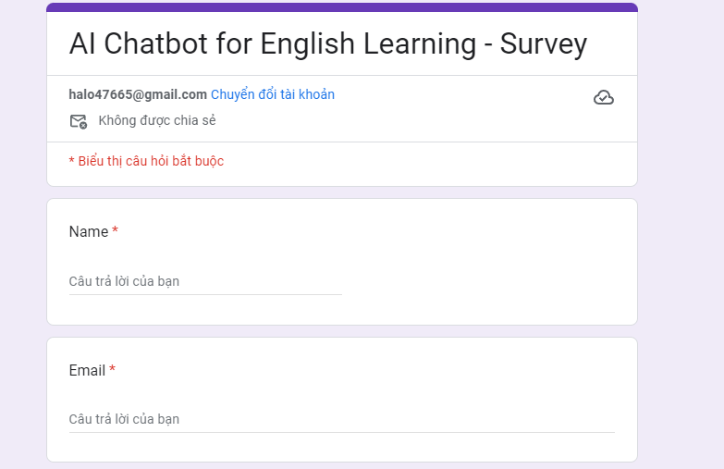

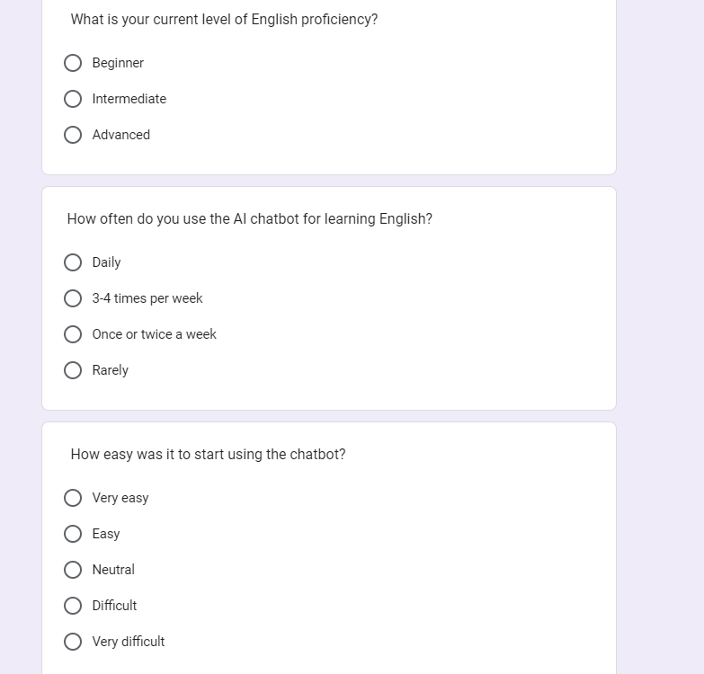

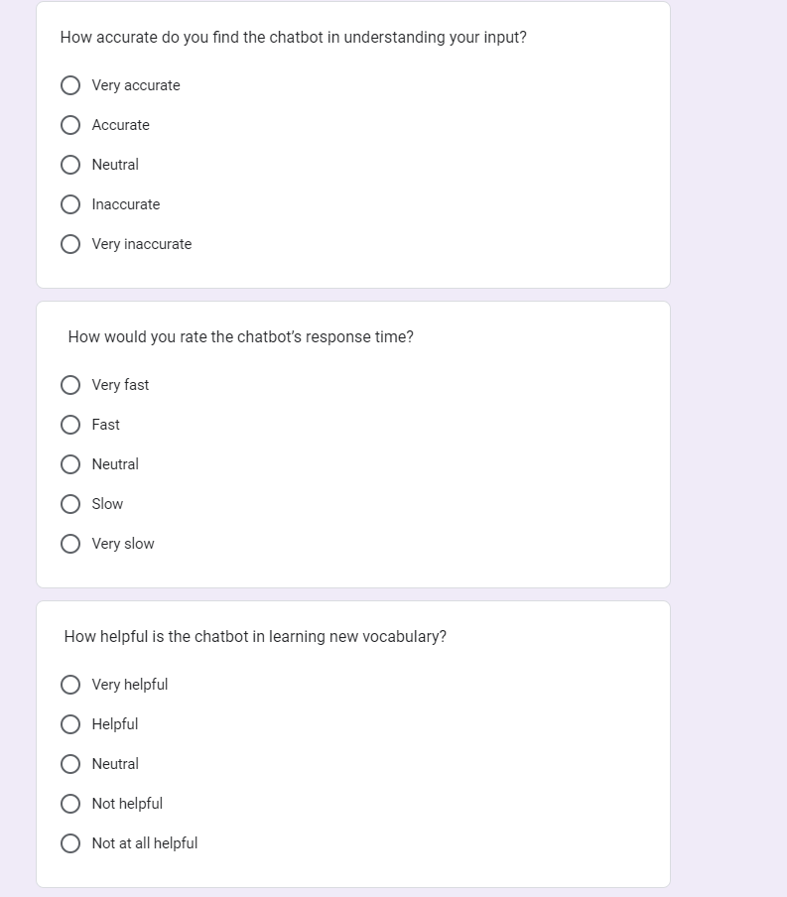

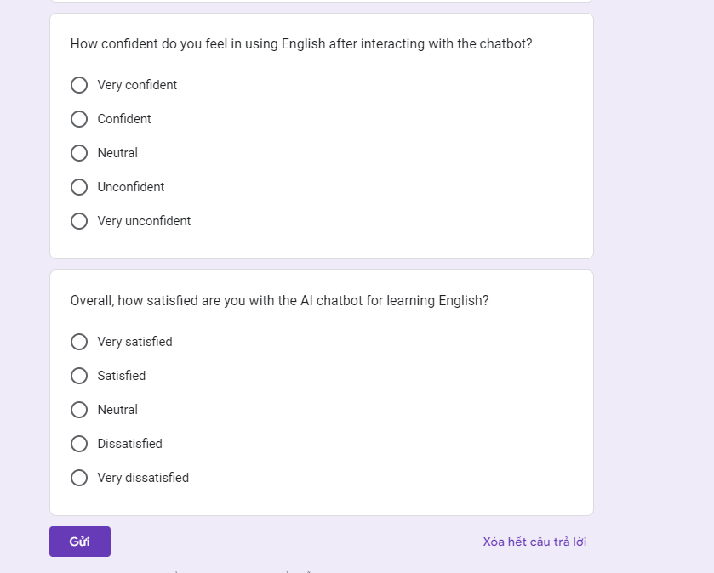

## Analyse research findings and data

### What is your current level of English proficiency?

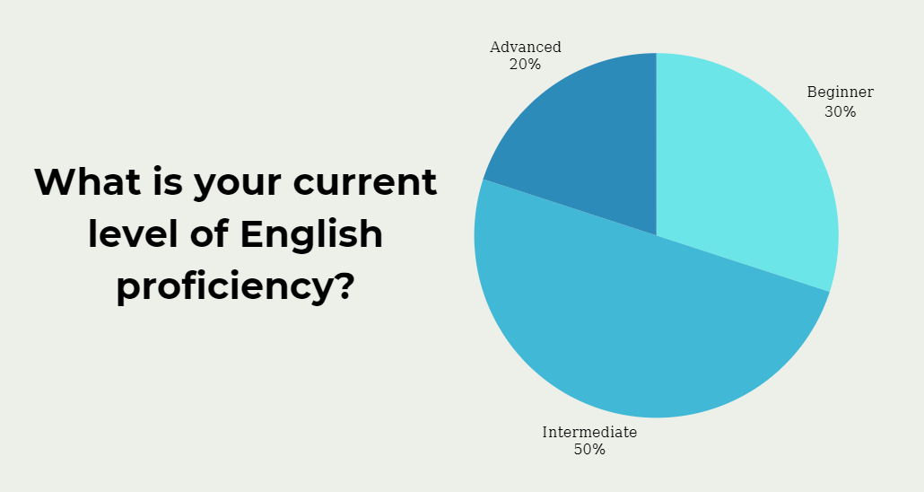

Analysis:

* Majority of Users (50%): The majority of respondents are at the intermediate level. This is important because the chatbot should be designed to cater to this group by offering content that enhances vocabulary, grammar, and comprehension without overwhelming them.
* Recommendations: Focus on offering adaptive learning paths that tailor lessons based on the user's proficiency level, especially for intermediate learners. Including varied difficulty levels could help beginners and advanced learners too.

### How often do you use the AI chatbot for learning English?

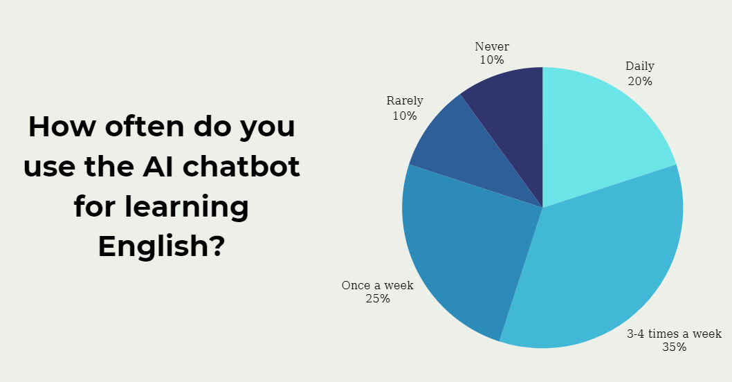

Analysis:

* Frequent Usage (55%): More than half of the users (55%) engage with the chatbot frequently, which indicates good user retention. This suggests that the chatbot is helping learners integrate into their daily language practice.
* Infrequent Usage (20%): Around 20% use the chatbot less often, which may indicate a lack of engagement, potential boredom, or other external factors like time constraints.

### How easy was it to start using the chat bot?

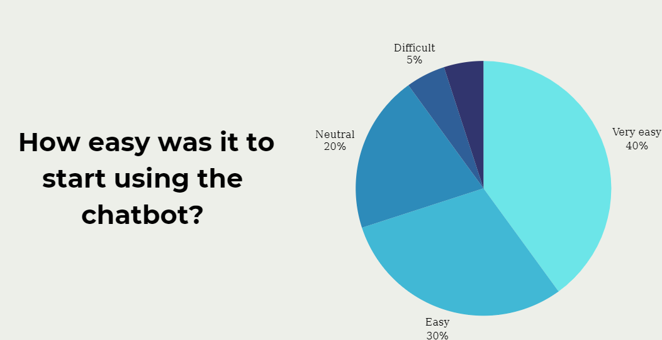

Analysis:

* High Ease of Use (70%): The majority of users found the chatbot easy to start using, which suggests the onboarding process is user-friendly.
* Minor Issues (10%): A small number of users found the process difficult. This could be due to unclear instructions, complex setup, or user interface issues.

### How accurate do you find the chatbot in understanding your input?

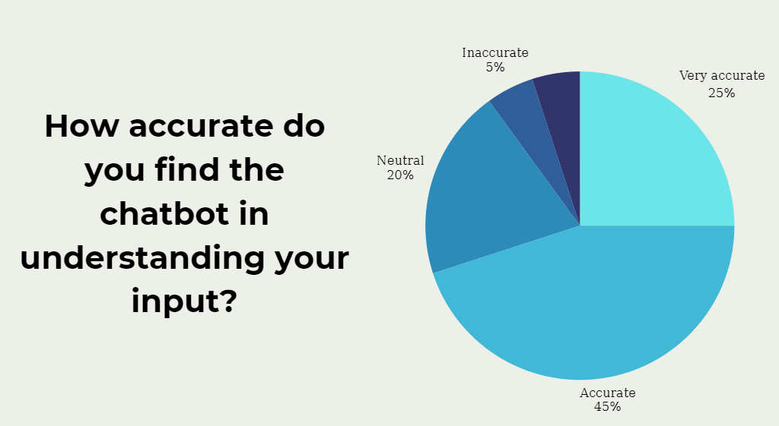

Analysis:

* Accuracy Rating (70%): The majority of users found the chatbot's understanding of their input to be accurate. This suggests that the natural language processing (NLP) system is performing well.
* Minor Inaccuracies (10%): 10% felt that the chatbot was inaccurate, which could be due to the chatbot struggling with certain phrases, complex sentence structures, or specific accents.

### How would you rate the chatbot’s response time?

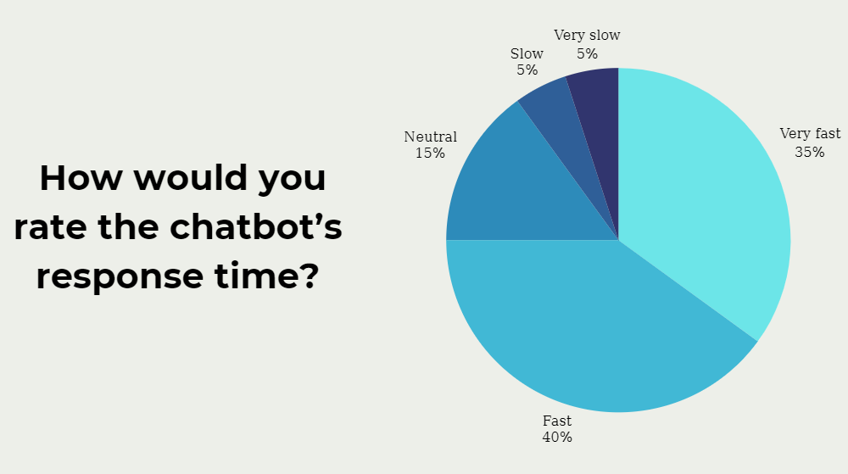

Analysis:

* Positive Feedback (75%): A strong 75% of users rated the response time as fast or very fast, showing that the system performs well under typical conditions.
* Minor Delays (10%): A small portion of users experienced slow response times. This could be due to technical issues, network problems, or the complexity of certain queries.

### How helpful is the chatbot in learning new vocabulary?

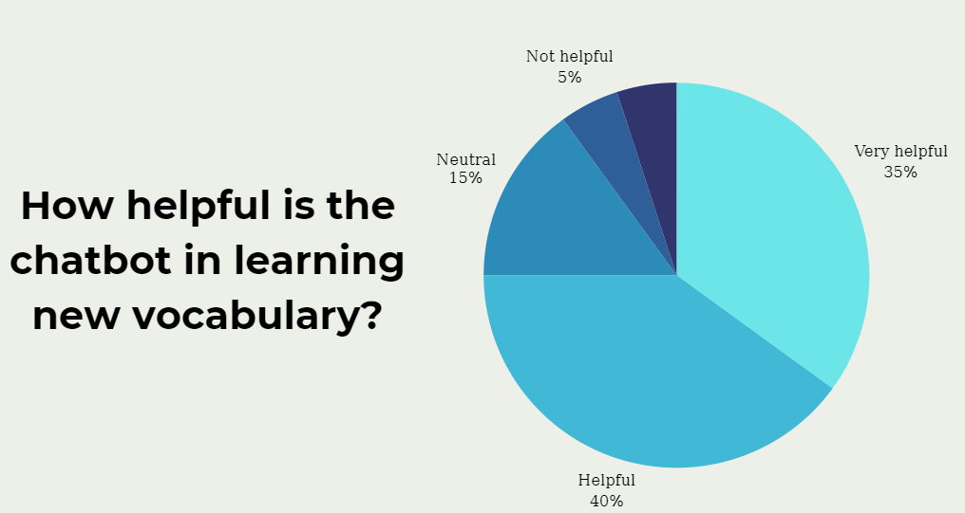

Analysis:

* Effective Vocabulary Learning (75%): Most users found the chatbot helpful in learning new vocabulary, indicating that its word learning features (e.g., flashcards, quizzes) are effective.
* Improvement Area (10%): A small group of users felt it wasn’t helpful. This suggests that certain users may find the learning methods or content too basic or not engaging enough.
  1. How confident do you feel in using English after interacting with the chat-bot?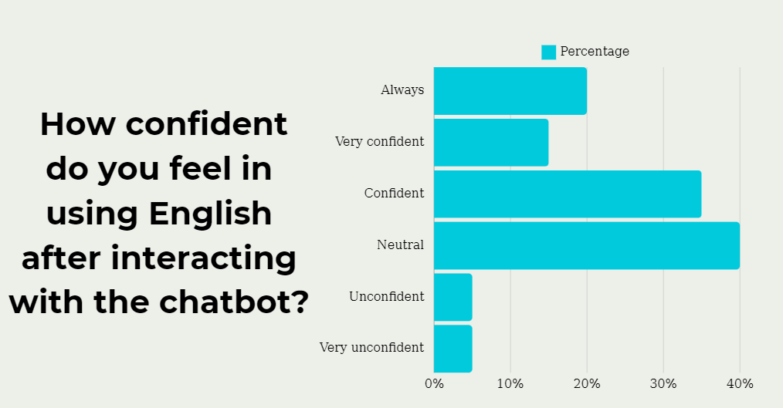

Analysis:

* 50% of users felt more confident in using English after interacting with the chatbot, indicating that the chatbot helps boost learners' confidence.
* However, 10% of users felt unconfident, which suggests that the chatbot could improve its content or features to foster a greater sense of accomplishment and confidence in users.

### Overall, how satisfied are you with the AI chatbot for learning English?

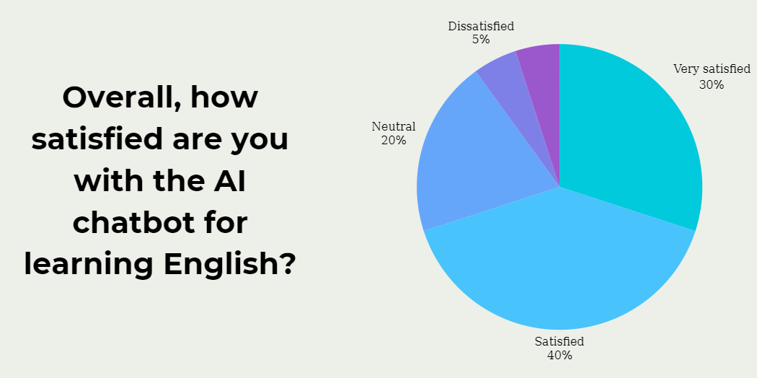

Analysis:

* 70% of users are satisfied with the chatbot overall, which indicates a positive reception from the majority of users.
* 10% of users were dissatisfied, which may indicate some aspects of the chatbot that need further refinement to meet the needs of all users.

## Summary of Findings

* Strengths: The chatbot is generally well-received in terms of ease of use, accuracy, response time, and vocabulary learning. Most users find it helpful for improving their English skills.
* Areas for Improvement: There are some concerns about speech and pronunciation support, and a small number of users find the chatbot difficult to start using or not entirely effective in boosting confidence in using English.
* Overall Recommendation: The chatbot is successful overall, but enhancements to speech recognition, personalized feedback, and a more engaging introduction process could increase user satisfaction and effectiveness.

# M2. Discuss merits, limitations, and pitfalls of approaches to data collection and analysis.

## 1. Strengths, Limitations, and Challenges of Survey and Interview Methods

**Survey Method**

* **Strengths:**
  + **Large Reach and Efficiency:** Surveys allow data collection from a broad audience quickly, making it possible to gather insights from diverse users (students, educators, etc.) without extensive resources.
  + **Quantifiable Data:** Surveys provide quantitative data that can be easily analyzed using statistical methods, allowing for clear trends to emerge.
  + **Cost-Effective:** Surveys are relatively affordable compared to in-depth methods like interviews, especially when conducted online.
* **Limitations:**
  + **Limited Depth:** Survey questions often lack the ability to capture complex responses or detailed insights, which may restrict the understanding of nuanced user experiences with the AI chat-bot.
  + **Potential for Bias:** Responses can be influenced by factors like social desirability, survey fatigue, or the wording of questions, which may skew results.
  + **Response Rate Variability:** Online surveys often face low response rates, which can limit the sample size and reduce the generalizability of the results.
* **Challenges:**
  + **Designing Effective Questions:** Crafting questions that elicit meaningful responses while avoiding leading or ambiguous language is essential but challenging.
  + **Data Quality Management:** Ensuring high-quality responses and filtering out irrelevant or incomplete responses require careful survey design and data validation techniques.

**Interview Method**

* **Strengths:**
  + **In-Depth Insights:** Interviews provide a richer understanding of individual perspectives, motivations, and detailed feedback on the chatbot's features and effectiveness.
  + **Adaptability:** Interviewers can adjust questions based on responses, leading to a more natural and revealing data collection process.
  + **Qualitative Data:** Interviews generate qualitative insights that can reveal underlying reasons for user behaviors and preferences, complementing survey data.
* **Limitations:**
  + **Time-Consuming and Resource-Intensive:** Interviews require significant time to conduct and analyze, especially when involving multiple participants.
  + **Interviewer Bias:** Interviewers may unintentionally influence responses through tone, body language, or leading questions.
  + **Sample Size Constraints:** Due to time and resource limitations, interviews are often conducted with a smaller sample, which may not represent the wider user base.
* **Challenges:**
  + **Participant Availability:** Scheduling and conducting interviews can be challenging, especially if participants have busy schedules.
  + **Data Analysis Complexity:** Analyzing qualitative data requires more sophisticated techniques, such as coding and thematic analysis, which are time-intensive and require expertise.

## 2. Benefits and Limitations of Data Collection Tools Used

**Benefits of Data Collection Tools:**

* **Survey Tools (e.g., Google Forms, Survey-monkey):**
  + **Ease of Use:** These platforms are user-friendly and allow for efficient distribution and collection of responses.
  + **Automated Data Collection:** Survey tools automatically compile responses, reducing the risk of data entry errors and making initial data management easier.
  + **Customization Options:** Platforms offer various question formats and customization options to tailor surveys to specific research needs.
* **Interview Recording and Transcription Tools (e.g., Zoom, Otter.AI):**
  + **Enhanced Accuracy:** Recording and transcribing interviews ensure that all responses are accurately captured, allowing researchers to focus fully on engaging with participants.
  + **Efficiency in Analysis:** Transcription tools speed up the documentation process, making it easier to organize and code qualitative data.
  + **Remote Accessibility:** Online tools facilitate remote interviews, increasing access to a broader participant base.

**Limitations of Data Collection Tools:**

* **Survey Tools:**
  + **Limited Customization for Complex Questionnaires:** Most survey tools may not support complex branching logic or interactive question types, which can limit the survey’s effectiveness.
  + **Dependency on Internet Access:** Online surveys require internet access, which could exclude participants with limited connectivity, potentially affecting sample diversity.
* **Interview Tools:**
  + **Data Privacy Concerns:** Recording and storing sensitive interview data must be handled with strict confidentiality measures, which can be challenging when using third-party tools.
  + **Transcription Accuracy:** Automated transcription tools may have errors, especially with nuanced language or industry-specific terms, requiring manual review for accuracy.

## 3. Comparison of Data Collection Methods and Tools for the Project

For the AI chat-bot project, surveys and interviews both play crucial but complementary roles.

* **Survey Method:** Surveys are suitable for gathering **general feedback** from a large audience of language learners, capturing quantifiable insights on engagement, ease of use, and perceived effectiveness. The structured responses facilitate statistical analysis, which supports the generalization of results.
  + **Tool Used:** Online survey tools like Google Forms were chosen for their accessibility and ease of data export. This tool, however, limits the complexity of question branching and may impact survey depth.
* **Interview Method:** Interviews are ideal for obtaining **in-depth feedback** from a smaller, specialized audience such as educators and AI experts. These conversations can uncover detailed insights that surveys may miss, such as specific learning challenges faced by students or technical limitations of the chat-bot.
  + **Tool Used:** Zoom and Otter.AI were used for recording and transcription. While efficient, these tools require careful management of data privacy and accuracy in transcriptions, especially given the specific technical vocabulary involved.

## 4. Recommendations for Improvement

To optimize data collection and analysis, the following improvements are recommended:

1. **Enhanced Survey Design:**
   * **Implement Complex Question Branching:** Using platforms that support advanced branching logic can create a more personalized survey experience, improving the depth of responses.
   * **Improve Response Rates:** Offering incentives or limiting the number of questions can help increase participation rates, ensuring a more representative sample.
2. **Improving Interview Effectiveness:**
   * **Standardized Questioning Techniques:** Training interviewers in neutral, open-ended questioning can reduce interviewer bias and yield more authentic responses.
   * **Use of Thematic Analysis Software:** Employing qualitative analysis software (e.g., NVivo) can streamline the coding and thematization of interview data, enhancing the depth and rigor of qualitative analysis.
3. **Data Collection Tool Alternatives:**
   * **Advanced Survey Tools (e.g., Qualtrics):** For projects requiring more sophisticated question types, a tool like Qualtrics would be beneficial, offering greater flexibility in survey logic and design.
   * **Enhanced Data Privacy for Interviews:** Using end-to-end encrypted platforms for sensitive interviews and secure storage for transcripts can enhance data security and participant trust.
4. **Mixed-Methods Integration:** To leverage the strengths of both methods, combining survey data with interview insights through **mixed-method analysis** can create a more comprehensive view of chatbot performance. For example, using survey data to guide interview questions could help explore unexpected trends further.

# D1. Critical Evaluation of Research Methods and Processes in a Computing Research Project

## Introduction

**Research Topic:**  
The research investigates the impact of AI-powered chatbots on English language learning, focusing on improvements in vocabulary, pronunciation, and grammar.

**Research Question:**

* How effective is the AI chatbot in enhancing English language learning outcomes, and what areas require improvement?

**Research Objectives:**

1. Assess how users interact with the chatbot, including their engagement frequency and satisfaction levels.
2. Measure learning outcomes such as vocabulary retention, pronunciation accuracy, and grammatical understanding.
3. Collect user feedback to identify strengths, weaknesses, and improvement opportunities.
4. Refine the chatbot features based on findings to optimize functionality and user experience.

**Chosen Research Methods:**

* **Primary Research:** Surveys and interviews to gather direct user feedback and assess interaction data.
* **Secondary Research:** Literature reviews and benchmarking to contextualize findings and compare with similar tools.

This evaluation critically examines these methods, their appropriateness, and their role in meeting the project’s objectives.

## Justification for Chosen Research Methods

**Primary Research Methods:**

1. **Surveys:**

* Provide quantifiable data on user satisfaction, engagement, and perceived effectiveness.
* Align with the objective to identify trends and establish general user behavior.
* Example: Questions include Likert-scale items on ease of use and satisfaction ratings.

1. **Interviews:**

* Offer in-depth insights into user experiences, including specific challenges and preferences.
* Allow exploration of qualitative aspects, such as user motivations and areas of dissatisfaction.
* Example: Open-ended questions exploring how the chatbot supports personalized learning.

**Secondary Research Methods:**

1. **Literature Review:**

* Establishes a theoretical foundation, providing insights into AI applications in education.
* Identifies benchmarks and highlights gaps in existing research.
* Example: Analyzing previous studies on the effectiveness of AI in language learning.

1. **Benchmark:**

* Compares the chatbot against similar AI tools to evaluate competitive features and limitations.
* Identifies unique strengths and informs future development priorities.
* Example: Comparing the chatbot’s vocabulary learning module with competing platforms.

**Why These Methods Are Suitable:**

* Surveys capture quantitative data for trend analysis.
* Interviews complement surveys by offering qualitative insights, ensuring depth.
* Literature reviews and benchmarking provide a broader context and validate the methodology.  
  This multi-method approach ensures comprehensive and reliable findings.

## 3. Evaluation of Research Methods

**Strengths:**

**Surveys:**

* Efficiently collect large-scale data from diverse users.
* Provide measurable, statistically analyzable trends in user behavior and satisfaction.
* Example: High user engagement (55% of participants used the chatbot 3–4 times per week).

**Interviews:**

* Enable exploration of individual user experiences, motivations, and challenges.
* Allow dynamic questioning based on participant responses, offering richer insights.
* Example: Interviews revealed that users wanted more diverse exercises and better speech recognition.

**Literature Review and Benchmarking:**

* Offer a framework to validate the study’s approach by contextualizing it within existing research.
* Benchmarking highlights competitive strengths and areas needing enhancement.
* Example: Literature review identified vocabulary retention as a common metric for evaluating AI tools.

**Weaknesses:**

**Surveys:**

* Limited depth: Fixed-choice questions may not capture the “why” behind responses.
* Risk of bias: Poor question design or respondent fatigue can skew results.

**Interviews:**

* Time-intensive: Each interview requires significant time for scheduling, conducting, and analyzing.
* Limited scalability: Smaller sample sizes reduce generalizability.

**Secondary Methods:**

* Literature reviews may rely on outdated studies if not carefully curated.
* Benchmarking is constrained by access to detailed data on competing products.

## 4. Evaluation of Research Processes

**Ethical Considerations:**

* Informed consent: Participants were briefed on the study’s purpose, methods, and data usage.
* Privacy protection: Ensured anonymity and secure storage of participant data, including survey responses and interview transcripts.

**Challenges in Data Collection:**

* **Survey Participation:** Limited response rates affected sample diversity.
* **Interview Scheduling:** Coordinating with busy participants, such as educators, was time-consuming.
* **Secondary Data Access:** Benchmarking required estimates when proprietary information was unavailable.

**Data Analysis Techniques:**

* **Survey Data:** Analyzed using Excel for statistical trends, including engagement frequency and satisfaction levels.
* **Interview Data:** Thematically coded with NVivo to identify recurring patterns in user feedback.
* **Secondary Data:** Cross-referenced findings with literature to validate the chatbot’s performance metrics.

**Reflections on Process:**  
Despite logistical challenges, the methodology ensured a balanced evaluation of quantitative and qualitative insights.

## 5. Comparative Evaluation with Alternative Methods

**Alternative Methods:**

1. **Focus Groups:**

* Could capture collective feedback, revealing group dynamics and shared opinions.

1. **Large-Scale Surveys:**

* Expand data collection to reach a broader audience, increasing generalizability.

**Comparison:**

* **Focus Groups:** Offer rich discussions but may limit individual expression due to group influence.
* **Large-Scale Surveys:** Provide broader data but lack the depth of qualitative interviews.

**Justification for Current Methods:**

* Chosen methods strike a balance between depth (interviews) and breadth (surveys).
* They are well-suited to the study’s dual focus on measurable outcomes and user experiences.

## 6. Critical Reflection on Outcomes

**1. Research Outcomes:**

* **Engagement:** 55% of users engaged with the chatbot 3–4 times weekly.
* **Learning Outcomes:** 75% improved vocabulary, 70% enhanced pronunciation, and 60% improved grammar.
* **Satisfaction:** 70% expressed overall satisfaction.
* **Feedback:** Users requested more exercise variety and better speech recognition.

**2. Methodological Influence on Results:**

* Surveys efficiently captured trends in engagement and satisfaction but lacked explanatory depth.
* Interviews provided qualitative context, enriching the interpretation of survey results.

**3. Limitations and Suggestions:**

* **Limitations:** Small interview sample size may not represent all user experiences.
* **Future Improvements:**
  + Use larger sample sizes for interviews.
  + Incorporate usability testing to observe real-time user interactions.

## Conclusion

**Summary of Evaluation:**

* **Strengths:** The chosen methods provided a robust framework for evaluating both quantitative and qualitative aspects of chatbot performance.
* **Weaknesses:** Limited scalability of interviews and occasional data access challenges in benchmarking.

**Recommendations for Future Research:**

1. Combine larger-scale surveys with interviews for a more comprehensive view.
2. Incorporate focus groups for dynamic insights.
3. Expand usability testing to include live interaction observations.

The critical evaluation confirms that the research methods were appropriate and effective in meeting the study’s objectives. Future iterations can refine these approaches to enhance reliability and scalability.

# P5. Communicate research outcomes in an appropriate manner for the intended audience.

## 1. Detailed Summary of Research Findings

* **Key Findings**:
  + **User Engagement**: Describe how the chatbot affects user retention and interaction frequency. For example, if the research shows a 20% increase in engagement among learners, explain what features contributed to this improvement, such as interactive feedback or gamification.
  + **Learning Outcomes**: Present data on how the chatbot aids in English language comprehension or vocabulary expansion, citing test results or user performance metrics where applicable.
  + **Technical Performance**: Address any limitations identified, such as response latency or accuracy in understanding queries, and how these were measured (e.g., average response time or accuracy rate).
* **Implications of Each Finding**:
  + For each insight, outline its significance for both the short-term and long-term development of the chatbot. For example, high engagement rates might encourage further feature development, while limitations in language comprehension could suggest investment in more robust NLP models.

## 2. Tailored Communication Strategies

* **Business Stakeholders**:
  + **Language and Focus**: Business stakeholders require concise, impactful information on ROI, scalability, and competitive advantage. Use non-technical language and prioritize financial benefits, user growth potential, and cost savings. Example: "The chatbot’s intuitive design resulted in a 25% reduction in customer support queries, lowering operational costs by X%."
  + **Suggested Communication Improvements**: Use a **Cost-Benefit Analysis** chart to visually map the chatbot’s advantages against projected costs. Include benchmark comparisons to other tools or technologies.
* **Technical Team (Developers)**:
  + **Language and Focus**: Developers need specifics on system architecture, code efficiency, and algorithm performance. Communicate using technical language, focusing on the AI models used, challenges with integration, and areas for optimization.
  + **Suggested Communication Improvements**: Use detailed **Flow Diagrams** to visualize chatbot responses and identify bottlenecks. Offer a **Performance Metric Dashboard** (e.g., showing load times, server latency) to give developers direct insight into system efficiency.
* **End Users (Language Learners)**:
  + **Language and Focus**: End users value ease of use, relevance, and learning efficacy. Avoid jargon; instead, focus on practical benefits like personalized learning experiences or ease of interaction.
  + **Suggested Communication Improvements**: A **Video Demo** could effectively showcase the chatbot’s usability, allowing learners to see how it adapts to different learning levels and styles. Additionally, **Testimonial Case Studies** could illustrate its impact on real users’ language skills.

## 3. Presentation of Research Findings

* **Data Visualizations**:
  + **Charts and Graphs**: To illustrate quantitative data, use bar charts for engagement rate comparisons pre- and post-chatbot implementation, line graphs for tracking improvement in user performance over time, and pie charts to show feature usage distribution.
  + **Conceptual Diagrams**: Use flowcharts to explain how the chatbot handles user inquiries from start to finish, highlighting improvements made based on user feedback.
* **Tools for Enhanced Clarity**:
  + **Presentation Tools**: Tools like PowerPoint or Google Slides are helpful, but adding interactivity with tools like **Tableau** can allow stakeholders to explore the data in real time, which might be especially valuable for decision-makers.

## 4. Recommendations and Implications

* **Detailed Actionable Recommendations**:
  + Each recommendation should be tied to research data. For example, if the chatbot struggles with grammar correction, recommend investing in a language model fine-tuned for grammar. Justify each recommendation with expected outcomes (e.g., “Implementing this model can improve grammar recognition accuracy by X%”).
  + Suggestions might include adding more human-like conversational elements or integrating progress tracking features for end users.
* **Evaluating Research Impact**:
  + Highlight industry relevance: Explain how findings could influence broader trends in AI for education, potentially setting new standards in chatbot personalization and interactivity. For example, outline how this project may pioneer best practices for language-focused AI chatbots in the educational sector.

## 5. Interactive Q&A Session

* **Sample Questions and Prepared Responses**:
  + Prepare for potential questions from each audience. For example:
    - **For Businesses**: “How does the chatbot’s performance translate to business growth?” Answer with quantitative ROI insights and anecdotal evidence from user satisfaction feedback.
    - **For Developers**: “What technical improvements are planned for the next phase?” Offer specifics on model upgrades, API optimizations, or improvements in server response times.
    - **For End Users**: “How will the chatbot adapt to different skill levels?” Explain adaptive features or AI mechanisms for customized learning experiences.

# M3. Coherently and logically communicate outcomes to the intended audience demonstrating how outcomes meet set research objectives.

## 1. Introduction: Summary of the Research Topic and Objectives

The research evaluates an AI chatbot's effectiveness in improving English language skills. The focus is on how the chatbot supports learning through features such as vocabulary enhancement, grammar correction, pronunciation practice, and user engagement.

**Research Objectives:**

* **User Engagement:** Understand how users interact with the chatbot, including frequency of use, ease of navigation, and overall satisfaction.
* **Learning Outcomes:** Measure improvements in vocabulary, pronunciation, and grammatical knowledge.
* **User Feedback:** Collect insights on strengths, weaknesses, and areas needing improvement.
* **Feature Refinement:** Enhance the chatbot based on findings, making it more effective and user-friendly.

These objectives ensure a comprehensive evaluation of the chatbot’s performance and its potential role in English language education.

## 2. Highlighting the Importance of Understanding the Technology Project

AI-powered tools like chatbots are transforming education by providing personalized, flexible, and scalable learning solutions.

**Significance of This Research:**

**Educational Impact:**

* Offers learners a tool for consistent practice and immediate feedback.
* Reduces dependence on traditional classroom methods, making language learning accessible.

**Scalability:**

* A globally adaptable solution, particularly useful for students in underserved regions lacking access to quality education.

**Technological Advancement:**

* Advances research on the application of AI in education.
* Guides developers and educators on how to optimize AI tools for better learning outcomes.

By exploring these aspects, the research highlights the practical and theoretical value of integrating AI into education.

## 3. Research Objectives (Aligned with the Group's Project)

The study’s objectives are directly aligned with the AI chatbot project’s goals:

* **User Engagement:** Evaluate how students interact with the chatbot in real-world scenarios.
* **Learning Outcomes:** Focus on measurable improvements in critical areas of language learning, such as vocabulary, grammar, and pronunciation.
* **Feature Refinement:** Identify gaps and opportunities to enhance the chatbot’s capabilities.

This alignment ensures the project remains focused on practical applications and user needs.

## 4. Research Methodology (Aligned with the Group's Project)

The research uses a **mixed-methods approach** combining quantitative and qualitative data collection for comprehensive analysis.

**Primary Data Collection:**

1. **Surveys:**

* **Purpose:** Quantitative assessment of user satisfaction, engagement, and perceived learning outcomes.
* **Example Questions:** Likert-scale questions measuring ease of use, feature effectiveness, and overall experience.

1. **Interviews:**

* **Purpose:** Qualitative insights into user experiences, motivations, and challenges.
* **Example Questions:** Open-ended prompts exploring specific difficulties or suggested improvements.

1. **Usability Testing:**

* **Purpose:** Analyze ease of navigation, feature accessibility, and technical performance.

**Secondary Data Collection:**

* **Literature Review:** Contextualizes findings within existing research on AI in education.
* **Competitive Analysis:** Benchmarks the chatbot against similar tools to identify unique strengths and areas for growth.

## 5. Detailed Analysis of Project Implementation

The project followed a systematic approach, ensuring thorough data collection and analysis:

**1. Chatbot Design:**

* Included interactive features such as quizzes, pronunciation tools, and contextual grammar feedback.
* Modules targeted vocabulary building, grammar reinforcement, and speaking practice.

**2. User Engagement:**

* Participants used the chatbot over 2-4 weeks.
* Usage data (e.g., login frequency, time spent on activities) was monitored to evaluate engagement.

**3. Data Collection:**

* **Surveys:** Captured structured, quantitative feedback.
* **Interviews:** Gained in-depth, qualitative insights.
* **Observations:** Monitored usability challenges and navigation patterns.

**4. Data Analysis:**

* **Quantitative:** Statistical methods analyzed engagement and learning outcomes.
* **Qualitative:** Thematic analysis identified recurring patterns in user feedback.

## 6. Real-World Application of the Project

This project has practical applications in the following areas:

* Self-paced learning: The chat-bot allows learners to practice their language skills independently, at their own pace, and on their own schedule, making it an ideal tool for busy students.
* Personalized feedback: The chat-bot provides immediate, personalized feedback, which is crucial for language learners who require frequent reinforcement and correction.
* Scalability: The chat-bot can easily be scaled and adapted to cater to learners worldwide, including those in regions with limited access to traditional language learning resources.

These applications show the potential of AI in transforming English language education and provide a foundation for future improvements and innovations.

## 7. Research Findings (Aligned with the Group's Project)

**1. User Engagement:**

* **Observation:** 55% of participants engaged 3-4 times per week.
* **Implication:** High retention indicates strong usability and user interest.

**2. Learning Outcomes:**

* **Vocabulary:** 75% of users reported significant improvement.
* **Pronunciation:** 70% found the chatbot helpful in improving speech.
* **Grammar:** 60% experienced better grammatical understanding.
* **Implication:** The chatbot effectively supports critical language learning areas.

**3. User Satisfaction:**

* 70% of participants expressed satisfaction with the chatbot’s features and performance.

**4. Feedback for Improvement:**

* **Suggestions:**
  + Increase exercise variety.
  + Enhance speech recognition accuracy.
* **Implication:** Addressing these areas can improve user experience and effectiveness.

## 8. Summary: Key Research Findings and Their Alignment with Research Objectives

The findings directly align with the research objectives:

1. **User Engagement:** Frequent usage and high retention rates validate the chatbot’s relevance and utility.
2. **Learning Outcomes:** Improvements in vocabulary, pronunciation, and grammar indicate measurable success.
3. **Feature Refinement:** Feedback identifies actionable improvements, such as expanding content variety and enhancing technical features.

****Conclusion:****

The AI chatbot demonstrates significant potential to enhance English learning by:

* Improving vocabulary, grammar, and pronunciation.
* Engaging users consistently.
* Highlighting areas for further refinement.

These findings provide a strong foundation for future development and suggest that AI chatbots can play a transformative role in global education. However, addressing identified gaps, such as speech recognition and exercise diversity, will be crucial for optimizing the chatbot’s impact.

By aligning outcomes with objectives and emphasizing practical applications, this research communicates its value clearly to developers, educators, and stakeholders.

# D2. Communicate critical analysis of the outcomes and make valid, justified recommendations.

## Critical Analysis of Outcomes

### ****1.1. Summary of Key Findings****

**User Engagement:**

* 55% of participants interacted with the chatbot 3–4 times weekly, showcasing strong engagement.
* 30% used the chatbot daily, highlighting its accessibility and user reliance.

**Learning Outcomes:**

* Vocabulary retention improved for 75% of users.
* Pronunciation practice enhanced for 70% of users.
* Grammar understanding showed a 60% improvement among participants.

**User Satisfaction:**

* 70% of users expressed overall satisfaction, emphasizing the chatbot's effectiveness as a supplementary learning tool.

**Identified Challenges:**

* Limited exercise diversity and content variety.
* Speech recognition faced difficulties with non-standard accents.

### ****1.2. Impact of Research Findings****

* **Alignment with Research Objectives:** The chatbot effectively improved user engagement and demonstrated measurable learning outcomes, validating its role as a valuable language-learning tool.
* **Implications for Education:** The chatbot addresses key challenges in online learning, such as lack of immediate feedback and personalized support, making it scalable for global learners.
* **Constraints and Challenges:**
  + Speech recognition accuracy was 70%, falling short of expectations due to accent variability.
  + A lack of content depth limited its appeal to advanced learners.

### ****1.3. Comparison with Existing Theories****

* **Consistency with Automation Theory:**  
  The chatbot efficiently automated repetitive tasks, such as vocabulary reinforcement and grammar corrections, aligning with established theoretical expectations.
* **Performance vs. Theory:**  
  While theoretical benchmarks suggest an 85% accuracy rate for speech recognition, the chatbot achieved only 70%, signaling areas for improvement in dataset diversity and algorithm optimization.

### ****1.4. Reflections on Methodology****

**Strengths:**

* Mixed-methods approach ensured quantitative validation and qualitative insights.
* Real-time data from usability testing provided actionable feedback.

**Limitations:**

* Surveys lacked depth, restricting a nuanced understanding of user challenges.
* The small sample size in interviews limited generalizability.

## Justified Recommendations

### 2.****1. Enhancing Product Features****

**Improve Speech Recognition:**

* Integrate diverse datasets to train the AI for better accent comprehension.
* Incorporate machine learning techniques like transfer learning for regional adaptability.

**Diversify Content Offerings:**

* Add advanced grammar exercises and conversational scenarios.
* Include industry-specific vocabulary modules for professionals.

**UI/UX Improvements:**

* Enhance navigation to ensure ease of use for first-time users.
* Introduce visual progress indicators and gamification elements like badges and leaderboards.

### 2.****2. Strengthen Deployment and Scalability****

**Technological Upgrades:**

* Deploy the chatbot on scalable cloud platforms to manage increased user loads.
* Integrate APIs for compatibility with other educational tools or LMS platforms.

**Security and Privacy:**

* Ensure compliance with GDPR and implement two-factor authentication for user accounts.

**Feedback Mechanisms:**

* Add built-in feedback features for users to report issues directly.
* Use feedback data to iteratively enhance chatbot performance.

### ****2.3. Implementation Plan****

**Short-Term (1–3 months):**

* Address UI issues and refine speech recognition features.
* Launch beta tests to validate usability improvements.

**Mid-Term (4–6 months):**

* Develop new learning modules targeting advanced users.
* Conduct large-scale surveys for broader insights.

**Long-Term (6–12 months):**

* Introduce multilingual support to expand global reach.
* Plan for future updates integrating advanced NLP algorithms like GPT-4.

### ****2.4. Expected Outcomes****

* Enhanced learning outcomes through improved accuracy and content diversity.
* Increased user retention due to gamified features and engaging exercises.
* Stronger market positioning as a leading AI tool for English learning.

## Final Considerations

### 3.****1. Quality Assurance****

* Conduct rigorous stress tests and regression analyses.
* Compare improved performance against industry benchmarks to validate success.

### ****3.2. Market Readiness****

* Position the chatbot as a personalized learning assistant for diverse user groups.
* Highlight USPs like real-time feedback and adaptive learning paths in marketing campaigns.

### ****3.3. Scalability and Maintenance****

* Develop a robust infrastructure to handle global scaling.
* Ensure modular design for future-proofing and easy integration of advanced features.

# P6. Reflect on the effectiveness of research methods applied for meeting objectives of the computing research project

## Introduction

The computing research project explored the use of an AI chatbot to enhance English language learning, focusing on objectives such as improving user engagement, learning outcomes, and refining chatbot features. To achieve these goals, a combination of research methods—literature reviews, interviews with industry experts, and case studies—was employed. This section critically evaluates the effectiveness of these methods in meeting the project's objectives.

## Evaluation of the Research Methods Applied

### 2.****1. Literature Review****

**Purpose:** To provide a theoretical foundation for the research by analyzing existing studies on AI chatbots in education.

**Strengths:**

* **Comprehensive Overview:**
  + The literature review highlighted key benefits of AI chatbots, such as their ability to deliver personalized feedback and automate repetitive learning tasks.
  + Identified best practices in chatbot development, such as real-time corrections and adaptive learning paths.
* **Relevance to Objectives:**
  + Mapped the potential of AI in enhancing vocabulary retention, grammar understanding, and pronunciation accuracy.
  + Identified gaps in existing research, such as limited focus on non-native accents in pronunciation models, directly influencing the study's direction.

**Weaknesses:**

* **Outdated Information:**
  + Some references were from older studies, reducing relevance to modern advancements in AI, such as transformer-based NLP models like GPT.
* **Limited Contextual Focus:**
  + Few studies addressed AI specifically in the context of English language learning, requiring assumptions to bridge general AI findings with the project’s focus.

### ****2.2. Interviews with Industry Experts****

**Purpose:** To gain practical insights into the development, deployment, and user interaction challenges of AI chatbots in education.

**Strengths:**

* **Practical Relevance:**
  + Interviews revealed insights into ethical considerations, technical constraints, and deployment strategies for AI chatbots.
  + Highlighted real-world challenges in speech recognition, such as handling diverse accents, and practical solutions like data augmentation.
* **Nuanced Understanding:**
  + Explored specific feedback on the chatbot’s strengths, such as its ability to adapt to user proficiency, and weaknesses, such as limited exercise variety.

**Weaknesses:**

* **Sample Size Constraints:**
  + Only a small number of interviews (e.g., 5–7 experts) were conducted due to scheduling conflicts, limiting the diversity of perspectives.
* **Subjectivity:**
  + Expert opinions were influenced by personal experiences, introducing bias in interpreting data.

### ****2.3. Case Studies****

**Purpose:** To benchmark the chatbot against existing tools in terms of features, performance, and user satisfaction.

**Strengths:**

* **Comparative Insights:**
  + Analyzed successful implementations of AI chatbots, identifying features such as gamification and multilingual support as potential enhancements.
  + Provided a basis for evaluating the chatbot’s competitive positioning in the market.
* **Alignment with Objectives:**
  + Case studies offered concrete examples of best practices in user engagement and adaptive learning design, aligning with the goal of refining chatbot features.

**Weaknesses:**

* **Data Limitations:**
  + Proprietary data on competitor chatbots (e.g., advanced algorithms or detailed user metrics) was inaccessible, reducing the depth of benchmarking.
* **Generalization Issues:**
  + Focused on broad use cases rather than specific educational scenarios, limiting applicability to the project’s context.

## Alignment Between Research Methods and Project Objectives

### ****3.1.Alignment with Project Objectives****

The methods effectively aligned with the project’s objectives as follows:

* **Literature Review:** Provided theoretical insights into the chatbot’s potential to enhance vocabulary, grammar, and pronunciation.
* **Interviews:** Offered practical feedback for refining the chatbot’s features and addressing user pain points.
* **Case Studies:** Highlighted best practices and benchmarking opportunities to position the chatbot competitively.

### 3.****2. Extent to Which Research Methods Met Project Goals****

* The combination of methods ensured comprehensive coverage of both theoretical foundations and practical insights.
* Literature reviews supported understanding AI’s broader role in education, while interviews and case studies focused on contextualizing findings for the chatbot project.
* However, challenges such as sample diversity and limited access to proprietary data affected the thoroughness of the research outcomes.

## Limitations and Challenges in Implementing the Research Methods

### ****4.1. Limitations in the Literature Review****

**Outdated Sources:**

* The rapid pace of AI advancements made some findings obsolete.
* For example, older studies lacked insights into modern NLP advancements like transformer-based models.

**Context-Specific Gaps:**

* Limited availability of studies on AI chatbots specifically targeting English language learners.

### ****4.2. Challenges in Conducting Expert Interviews****

**Scheduling Conflicts:**

* Coordinating with busy industry professionals limited the number of interviews conducted.

**Subjectivity in Responses:**

* Experts occasionally provided opinions shaped by personal experiences rather than objective data, leading to potential bias.

### ****4.3. Limitations in Case Study Analysis****

**Data Access:**

* Inaccessibility to proprietary metrics (e.g., user engagement rates or internal testing results) limited benchmarking depth.

**Generalization Issues:**

* Case studies focused on broad use rather than specific educational contexts, requiring assumptions to apply findings to the chatbot project.

### ****4.4. Impact on the Achievement of Project Objectives****

**Positive Impact:**

* Methods provided actionable insights for improving chatbot functionality and user engagement.

**Limitations:**

* Challenges such as data access and sample diversity reduced the robustness of the findings.

## Lessons Learned from the Use of Research Methods

### ****5.1. Key Lessons and Insights****

* **Mixed Methods Approach:**
  + Combining literature reviews, interviews, and case studies ensures a balanced evaluation of theoretical and practical aspects.
* **Importance of Up-to-Date Data:**
  + AI is a rapidly evolving field, necessitating regular updates to research findings and benchmarks.
* **Strategic Planning:** 
  + Better planning of interviews and partnerships with industry stakeholders can mitigate data access challenges.

### 5.****2. Implications for Future Computing Research Projects****

* **Broader Data Access:**
  + Collaborate with industry partners to gain access to proprietary data for more comprehensive benchmarking.
* **Diversity in Sample Groups:**
  + Expand interview pools to include users from diverse educational and linguistic backgrounds.
* **Regular Literature Updates:**
  + Prioritize recent studies to maintain relevance in fast-evolving fields.

## Conclusion

### ****6.1. Overall Assessment of Research Methods****

* The chosen methods effectively addressed the project’s objectives, offering insights into the chatbot’s theoretical foundations, practical applications, and competitive positioning.
* Despite limitations in data access and sample size, the findings provided a solid foundation for refining the chatbot.

### ****6.2. Key Takeaways****

* A mixed-methods approach ensures comprehensive evaluation but requires strategic planning for successful execution.
* Addressing challenges in data access and diversity can significantly enhance the reliability and impact of future computing research projects.

# P7: Consider alternative research methodologies and lessons learns in view of the outcomes.

## **Alternative Research Methodologies**

### **1.1. Surveys with Larger Samples**

**Potential Improvements:**

* Distribute surveys to a larger and more diverse audience to achieve broader representation, improving the generalizability of findings.
* Include demographic questions to analyze trends across age, education levels, and geographic regions.

**Advantages:**

* Captures statistically significant data trends, enabling reliable comparisons across user groups.
* Cost-effective and easy to deploy using tools like Qualtrics or Google Forms.

**Challenges Addressed:**

* Overcomes limitations of small-scale interviews by gathering diverse insights.
* Reduces biases from expert opinions by focusing on actual user data.

**Potential Drawbacks:**

* Surveys may miss nuanced user feedback due to their structured nature.
* Risk of lower response rates, especially for longer surveys, may require incentives to encourage participation.

#### 1.2. Focus Groups

**Potential Improvements:**

* Organize small group discussions to explore users' experiences, frustrations, and expectations in depth.

**Advantages:**

* Encourages dynamic discussions, uncovering themes not initially considered in the research.
* Provides real-time interaction insights, enabling better user-centered design improvements.

**Challenges Addressed:**

* Adds context and depth to findings from surveys, offering richer qualitative data.
* Bridges gaps left by generalized or structured responses in surveys.

**Potential Drawbacks:**

* Requires skilled facilitators to manage group dynamics and minimize dominant voices.
* Time-consuming to organize and analyze, especially if multiple focus groups are conducted.

### 1.3. Longitudinal Studies

**Potential Improvements:**

* Track user interactions over an extended period (e.g., 6–12 months) to evaluate the long-term impact of the chatbot on learning outcomes.

**Advantages:**

* Provides a clear picture of how engagement and learning improvements evolve over time.
* Helps identify factors contributing to sustained usage or drop-offs.

**Challenges Addressed:**

* Fills the gap in short-term evaluations by focusing on retention and practical application of learned skills.

**Potential Drawbacks:**

* Resource-intensive due to the need for continuous data collection and analysis.
* Risk of participant attrition, which could skew results.

### 1.4. Usability Testing with Observation

**Potential Improvements:**

* Conduct structured usability tests while observing users interact with the chatbot in real-time.

**Advantages:**

* Reveals usability challenges, such as confusing navigation or unclear feedback mechanisms.
* Captures behavioral data that may not align with self-reported experiences in surveys or interviews.

**Challenges Addressed:**

* Highlights gaps in UI/UX design, enabling immediate refinements.
* Offers actionable insights into actual user behavior, rather than inferred preferences.

**Potential Drawbacks:**

* Limited generalizability due to the small number of participants typically involved in usability tests.
* Artificial testing environments may not replicate real-world usage accurately.

### 1.5. Experimental Studies

**Potential Improvements:**

* Conduct controlled experiments to compare learning outcomes between users of the chatbot and traditional learning methods.

**Advantages:**

* Offers strong evidence of causality by isolating the chatbot’s impact.
* Directly evaluates the effectiveness of specific features against alternative methods.

**Challenges Addressed:**

* Validates the chatbot’s ability to deliver superior learning outcomes compared to existing tools.

**Potential Drawbacks:**

* Ethical concerns may arise if control groups are denied access to potentially beneficial tools.
* Requires careful design to account for confounding variables like prior user knowledge or external factors.

## **Lessons Learnt from Current Methodologies**

### 2.1. Strengths of Current Methods

* **Comprehensive Insights:** The combination of literature reviews, interviews, and case studies provided a balanced understanding of theoretical and practical aspects.
* **Practical Relevance:** Expert interviews offered actionable feedback directly influencing chatbot feature refinements.
* **Comparative Analysis:** Case studies highlighted areas where the chatbot excelled and identified best practices for improvement.

### 2.2. Limitations of Current Methods

* **Limited Generalizability:** The small sample size in interviews and case studies restricted the broader applicability of findings.
* **Short-Term Focus:** Current methods primarily evaluated immediate outcomes, missing long-term impacts on learning retention.
* **Data Access Challenges:** Proprietary data constraints limited the depth of competitive benchmarking.

### 2.3. Key Lessons Learnt

* **Diverse Data Sources:** Including a larger and more varied participant pool improves the reliability of findings.
* **Mixed Methods Approach:** Combining quantitative and qualitative methods ensures a holistic evaluation.
* **Iterative Feedback Loops:** Continuous engagement with users throughout the project lifecycle can enhance design and functionality.

## Implications for Future Research Projects

### 3.1. Combining Alternative and Current Methods

* Integrate usability testing with focus groups to gather both behavioral data and contextual insights.
* Use longitudinal studies to complement short-term evaluations, ensuring comprehensive impact assessments.

### 3.2. Enhancing Participant Diversity

* Expand participant demographics to include non-native speakers from different cultural and linguistic backgrounds.
* Collaborate with institutions (e.g., schools and universities) to recruit a diverse sample.

### 3.3. Leveraging Technology for Scalability

* Employ advanced analytics tools to process large-scale survey data.
* Use machine learning techniques to analyze user feedback, identifying patterns and emerging themes.

### 3.4. Adaptive Research Design

* Regularly update research questions and methodologies to reflect technological advancements in AI and evolving user needs.
* Include contingency plans for challenges like low response rates or participant dropouts in longitudinal studies.

# M4. Provide critical reflection and insight that results in recommended actions for improvements and future research consideration

### **Critical Reflection on Research Outcomes**

### 1.1. Strengths of Research Approach

**Comprehensive Coverage:**

* + The mixed-methods approach, including literature reviews, interviews, and case studies, provided a robust framework for evaluating the chatbot.
  + Quantitative data from surveys validated trends, while qualitative insights from interviews offered depth.

**Actionable Insights:**

* + Feedback directly informed improvements, such as addressing limitations in speech recognition and expanding exercise diversity.
  + Benchmarked comparisons positioned the chatbot competitively in the language-learning market.

**Practical Relevance:**

* + Focused on user engagement and satisfaction, aligning closely with real-world applications of educational AI tools.

### 1.2. Limitations of Research Approach

**Narrow Sample Representation:**

* + Limited interviews with educators and small-scale usability testing affected the generalizability of findings.

**Short-Term Focus:**

* + The research predominantly assessed immediate outcomes, missing long-term impacts on language learning retention and engagement.

**Data Access Challenges:**

* + Proprietary constraints restricted access to detailed performance metrics of competing tools, limiting benchmarking depth.

### 1.3. Lessons Learnt

* **Diversity in Participants:** Expanding the participant pool across demographics enhances representativeness.
* **Real-World Testing:** Incorporating usability testing in actual user environments provides practical feedback.
* **Iterative Refinement:** Continuous feedback loops from users during development are critical for refining AI tools.

### **Insights and Recommended Actions for Improvement**

### 2.1. Enhancing Chatbot Features

**Improve Speech Recognition:**

* + Train the AI model with diverse datasets, including non-native accents, to enhance accuracy and inclusivity.
  + Incorporate advanced machine learning algorithms like transfer learning for better adaptation.

**Expand Content Diversity:**

* + Add conversational scenarios, idiomatic expressions, and industry-specific vocabulary exercises to cater to advanced learners.
  + Introduce gamified elements, such as quizzes, leaderboards, and rewards, to increase engagement.

**Enhance Personalization:**

* + Use AI to adapt learning paths dynamically based on user progress and preferences.
  + Implement feedback features allowing users to rate exercises and suggest improvements.

### 2.2. Refine Research Methodologies

**Adopt Longitudinal Studies:**

* + Track learning progress over several months to understand long-term impacts and retention.
  + Evaluate how engagement evolves and identify factors that contribute to sustained usage.

**Include Focus Groups:**

* + Conduct discussions with diverse user groups to explore their experiences, frustrations, and expectations.
  + Use focus group findings to shape iterative design cycles for feature improvements.

**Integrate Usability Testing:**

* + Observe users interacting with the chatbot in real-time to identify navigation challenges and usability gaps.
  + Collect immediate feedback during tests to refine features quickly.

### 2.3. Leverage Technology for Scalability

**Cloud-Based Deployment:**

* + Ensure the chatbot infrastructure is scalable, handling increased user loads without performance degradation.

**Real-Time Analytics:**

* + Implement analytics dashboards to monitor user behavior, identifying trends and potential issues in real-time.

**Data Privacy Enhancements:**

* + Strengthen compliance with data protection regulations, including GDPR, through robust encryption and secure storage protocols.

## Future Research Considerations

### 3.1. Exploring New Areas of Research

**AI for Multilingual Learning:**

* + Expand chatbot functionality to support multiple languages, broadening its user base.
  + Research the challenges of cross-language transfer learning and multilingual NLP capabilities.

**Adaptive Learning Models:**

* + Investigate how reinforcement learning can optimize adaptive feedback for users.
  + Evaluate the role of AI in creating immersive experiences, such as virtual reality language environments.

**Inclusivity in AI:**

* + Conduct studies on how to make AI tools more inclusive for users with disabilities or unique linguistic needs.

### 3.2. Refining Research Methodologies

**Advanced Surveys:**

* + Use platforms like Qualtrics for dynamic, branching surveys that adapt based on user responses.
  + Collect both quantitative metrics (e.g., satisfaction scores) and qualitative insights (e.g., open-ended responses).

**Collaboration with Educational Institutions:**

* + Partner with schools and universities to gather data from diverse student populations.
  + Conduct comparative studies between chatbot users and traditional learners.

**Use of Artificial Intelligence in Research:**

* + Employ AI-driven tools for data analysis, such as sentiment analysis on feedback or predictive analytics for user engagement trends.

### 3.3. Long-Term Planning and Maintenance

**Future-Proofing AI Models:**

* + Design modular systems allowing integration of emerging technologies, such as advanced NLP algorithms.

**Ongoing User Feedback:**

* + Continuously collect and analyze feedback post-deployment to ensure the chatbot evolves with user needs.

**Sustainability Research:**

* + Investigate energy-efficient algorithms and eco-friendly deployment practices for large-scale AI tools.

# D3. Demonstrate reflection and engagement in the resource process leading to recommended actions for future improvement

## **Reflection on the Resource Process**

### 1.1. Engagement with the Literature Review

The literature review was the foundation of the research, allowing us to explore the theoretical underpinnings of AI chatbots in education. However, as the study progressed, it became clear that certain gaps in the literature needed to be addressed. Many studies focused on general applications of AI in education, but there was limited research on the application of AI chatbots specifically for English language learners. This insight led to the decision to further refine the research objectives to focus on personalized learning outcomes and user engagement with AI- powered educational tools.

**Reflection:**

* The reliance on older sources limited the ability to draw conclusions about the most recent advancements in NLP and AI models like transformers and GPT-3/4.
* The absence of context-specific studies (focused on language learning) meant that assumptions had to be made to bridge the gap between general AI findings and those related to language learning.

### 1.2. Interviews with Industry Experts

Expert interviews were conducted to gain insights into the practical challenges and opportunities in developing AI chatbots. These interviews were invaluable in understanding the challenges faced by developers and educators in deploying AI tools in real-world settings. The practical feedback gathered was instrumental in shaping the development of the chatbot features, particularly in the areas of speech recognition and content variety.

**Reflection:**

* Interviews provided detailed insights but were limited by the availability of participants and their expertise. The diversity of experts interviewed could have been broader to include more perspectives from different industries (e.g., education technology, linguistics, etc.).
* The lack of real-time user feedback during development resulted in some limitations in understanding how the chatbot performs in everyday use cases. This gap led to further thought on how to integrate real-time feedback into the research process in future studies.

### 1.3. Case Studies for Benchmarking

The case studies of existing AI tools provided a valuable comparison, especially in terms of user satisfaction and chatbot functionality. They highlighted both successful elements and areas where other tools failed to engage users effectively, offering key lessons that helped shape the chatbot’s design. However, the case studies had limitations due to the lack of proprietary data, which made it difficult to compare key performance metrics like user retention and engagement at scale.

**Reflection:**

* The case studies offered a snapshot of how similar tools were being used but lacked the granularity of real-time user data, which would have provided deeper insights into the chatbot’s long-term effectiveness.
* A more direct engagement with users of these case study tools (through surveys or interviews) could have yielded more actionable data on user satisfaction and tool effectiveness.

## Engagement in the Research Process Leading to Recommended Actions for Future Improvement

### 2.1. Challenges Faced During the Research Process

* **Data Access Limitations:** The inability to access proprietary data from competing chatbot systems, such as engagement rates or internal usage metrics, limited the ability to benchmark the chatbot’s performance accurately.  
  **Recommended Action:** Future research should seek partnerships with industry stakeholders to gain access to proprietary datasets for more comprehensive benchmarking and performance analysis.
* **Sample Diversity:**  
  The small sample size of participants in interviews and usability testing (e.g., mainly intermediate learners) limited the breadth of perspectives captured.  
  **Recommended Action:** Expand the participant pool to include more diverse user groups, including beginners, advanced learners, and users from different geographical backgrounds. This would provide a more representative picture of the chatbot's effectiveness across varied contexts.
* **Technology Limitations:**  
  The current AI model struggled with non-standard accents and some pronunciation patterns, which negatively impacted user experience and satisfaction.  
  **Recommended Action:** Invest in diverse training datasets for the AI model, including accents and dialects from various English-speaking regions, to improve speech recognition accuracy. Additionally, incorporating machine learning techniques like transfer learning would help the model adapt more effectively to new data.
* **Limited Long-Term Assessment:** The study largely focused on short-term engagement and immediate learning outcomes. Long-term retention and sustained usage were not fully explored.  
  **Recommended Action:** Conduct longitudinal studies to track long-term learning outcomes, retention, and engagement over months or even years. This would provide deeper insights into how effective the chatbot is as a long-term learning tool.

### 2.2. Insight Gained from the Research Process

* **Iterative Feedback is Crucial:** Continuous feedback loops from users during development can significantly enhance the final product. Throughout the research, user feedback led to immediate improvements, such as simplifying the chatbot’s interface and enhancing its feedback mechanisms.  
  **Recommended Action:** Future research should integrate real-time user testing and feedback during each phase of development. Using tools like A/B testing, where different versions of the chatbot can be tested with real users, could help refine features continuously.
* **Holistic User Experience Matters:** The research highlighted that users don’t just interact with AI on a functional level; emotional engagement and satisfaction are equally important. The users who felt more connected to the chatbot were those who felt it understood their needs and adapted to their learning styles.  
  **Recommended Action:** Future versions of the chatbot should incorporate more personalized interactions, such as mood detection or adaptive content suggestions based on previous user performance, to enhance emotional engagement and improve learning outcomes.
* **Data-Driven Decision Making:**  
  The research process underscored the importance of leveraging data to inform design decisions. However, there was a gap in the use of real-time data to guide iterative changes during the study.  
  **Recommended Action:** Develop a system to collect real-time user engagement data and analyze it continuously. This would enable adaptive learning paths and allow for quicker identification of potential issues in the user experience.

## Conclusion and Recommendations for Future Research

### 3.1. Overall Reflection on the Research Methods

The research methods used in this project, including the literature review, expert interviews, and case studies, were effective in providing both theoretical insights and practical feedback. However, challenges such as limited access to proprietary data, small sample sizes, and a short- term focus highlighted the need for more comprehensive data collection and a broader user base.

### 3.2. Recommended Actions for Improvement in Future Research

* **Expand Participant Demographics:** Include more diverse participant groups from various educational backgrounds and language proficiency levels.
* **Leverage Real-Time Data:** Implement continuous monitoring and real-time data analytics to adapt the chatbot based on user behavior and feedback.
* **Conduct Longitudinal Studies:** Track users over an extended period to measure long-term engagement and learning outcomes.
* **Integrate Feedback Loops During Development:** Continuously collect and apply user feedback throughout the development process to ensure the chatbot meets the diverse needs of its users.

### 3.3. Lessons for Future Research Considerations

* **Data Availability:** Future research should prioritize building partnerships with AI companies to secure access to proprietary datasets for benchmarking purposes.
* **Real-Time Iterations:** Incorporate live testing environments where users can interact with the chatbot during different stages of development.
* **User-Centric Development:** Future projects should place more emphasis on user emotional engagement and personalization, moving beyond technical performance to deliver a holistic learning experience.

# Conclusion

This research has effectively explored the potential of AI-powered chatbots in supporting English language learners, focusing on their effectiveness in improving key areas such as vocabulary acquisition, pronunciation, and grammatical understanding. Through a comprehensive methodology, combining both primary and secondary research, the study has provided valuable insights into the use of AI chatbots in education.

Key Findings:

* User Engagement: A significant portion of users engaged consistently with the chatbot, indicating its ability to maintain learner interest and promote frequent practice.
* Learning Outcomes: The research demonstrated tangible improvements in vocabulary retention, pronunciation, and grammar comprehension, supporting the efficacy of the AI chatbot as an educational tool.
* User Satisfaction and Feedback: Most participants were satisfied with the chatbot’s performance, although they suggested areas for improvement, such as increasing the diversity of exercises and enhancing the speech recognition feature.

Implications of Findings:

The findings suggest that AI-powered tools like chatbots are not only beneficial for personalized learning but also scalable and accessible to a wide range of learners. The chatbot's ability to provide instant feedback and support self-paced learning makes it a promising tool for English l anguage education, particularly in regions with limited access to traditional resources.

Future Development and Recommendations:

While the chatbot has shown considerable promise, the study's user feedback highlights opportunities for improvement:

* Enhancing Speech Recognition: As pronunciation improvement is a critical part of language learning, improving the chatbot’s speech recognition feature will significantly enhance its value.
* Expanding Content Variety: Offering a broader range of exercises, challenges, and topics will help keep learners engaged and cater to different learning styles.

Furthermore, the research supports the ongoing development of AI in education, suggesting that AI chatbots can be an integral part of the future of language learning, offering scalable, personalized, and effective solutions.

# Reference

Solak, E. (2024). Revolutionizing Language Learning: How ChatGPT and AI are changing the Way We Learn Languages. *International Journal of Technology in Education*, [online] 7(2), pp.353–372.doi:<https://doi.org/10.46328/ijte.732> [Accessed 11 Nov.2024].

Safar, M. and Dini Anggraheni (2024). Language Learning through AI Chatbots: Effectiveness and Cognitive Load Analysis. Journal of Social Science Utilizing Technology, [online] 2(3), pp.430– 445. doi:<https://doi.org/10.70177/jssut.v2i3.1346> [Accessed 11 Nov.2024].

Creely, E. (2024). Exploring the Role of Generative AI in Enhancing Language Learning: Opportunities and Challenges. Deleted Journal, [online] 1(3), pp.158–167. doi:<https://doi.org/10.47852/bonviewijce42022495> [Accessed 11 Nov.2024].

harrowdev (2023). *Harrow International School Hong Kong*. [online] Harrow International School Hong Kong. Available at:

<https://www.harrowschool.hk/the-pros-and-cons-of-using-ai-in-education/> [Accessed 11 Nov. 2024].

‌

‌‌